Multi-Line Insurance Policy and claims Management System

Milestone 4: Advanced Claim Processing, Security & Code Setup (Proof)

TEAM 7 MEMBERS :

NAME : R.HARIHARAN
ROLL NO : 822223104033
NM ID: 89EB08A5DEDC3B48B3349612B3B64218
EMAIL ID : hhariharan708@gmail.com

NAME : T.MUTHAMILSELVAN
ROLL NO : 822223104038
NM ID: 6C4BDAACAD9BB1FB31A47784B2502B96
EMAIL ID : t.muthamil555@gmail.com

Name :C.T.BHUVANESH
ROLL NO :822223104042
NM ID : DB1E37315FFD9B494E546AB8931A54DA
EMAIL ID : bhuvameshthi@gmail.com

Milestone 4: Advanced Claim Processing, Security & Code Setup
- Modify the Claim object to include an Approval Status field.
- Go to set up, Click on object manager, search for claim object and click on claim object.
- In the left side panel, click on fields and relationships.
- Click on new
- Select Datatype as picklist
- Label it as Approval Status
- Select enter values radio button
- Enter New, Submitted for Approval, Approved and Rejected line by line
- Field Name will be auto populated
- Click on Next, Next and Save.
2. Configure the Approval Process to route first to the Senior Adjuster, to the Department Manager, using two sequential steps.
- Go to setup, In the quick find box, Search for Approval process
- Select claim object for Manage approval process for
- Click on create new Approval Process and select use standard setup
- Give the process name as High Value Claim Approval
- Unique Name will be auto populated
- Click on Next

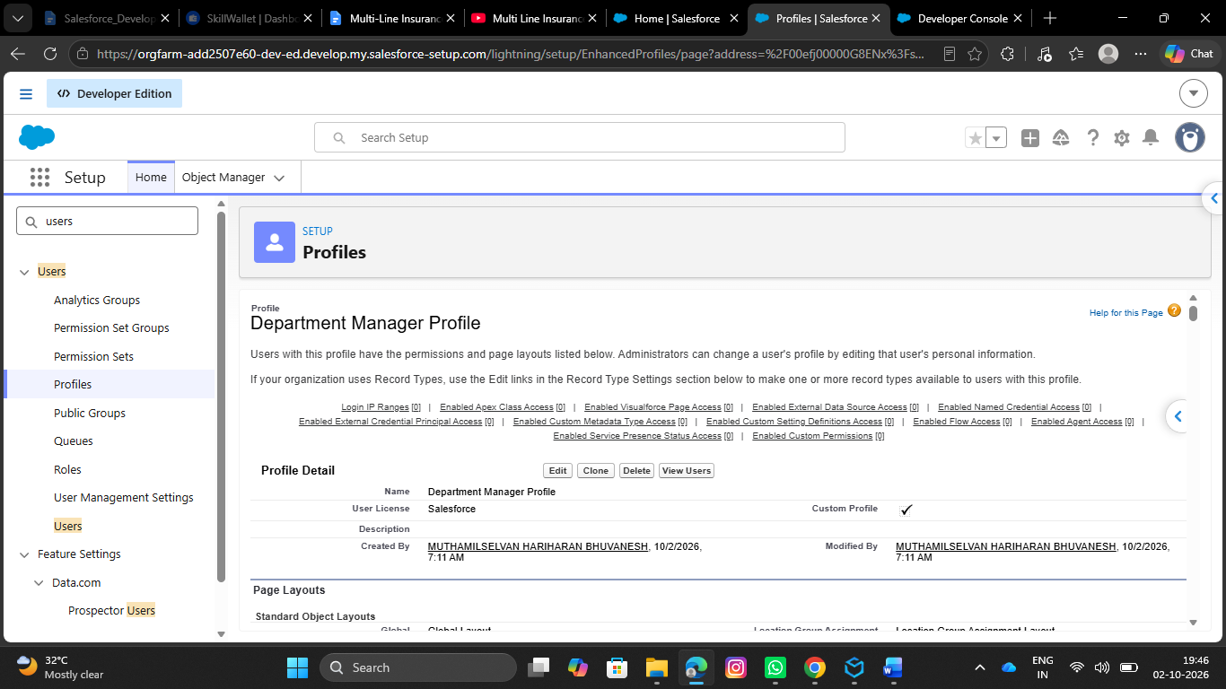
- Under specify entry criteria, Select criteria are met for Use this approval process
- Criteria includes:
- Claim amount greater than 50000
- Click on Next

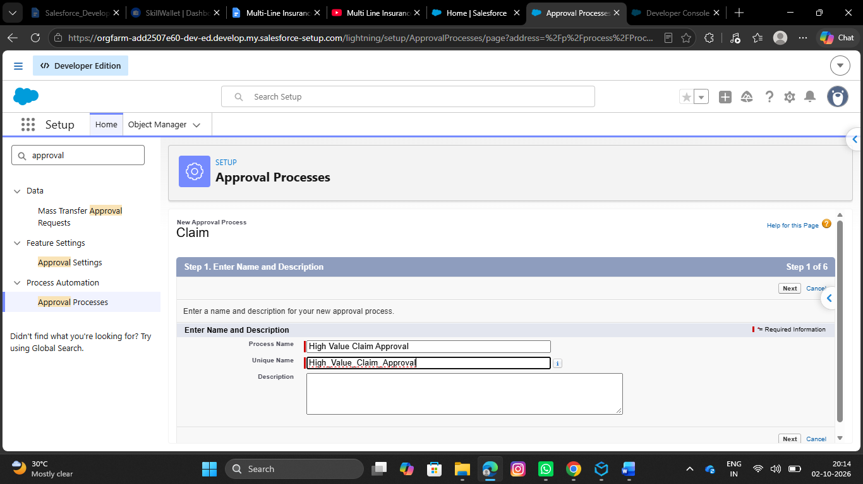
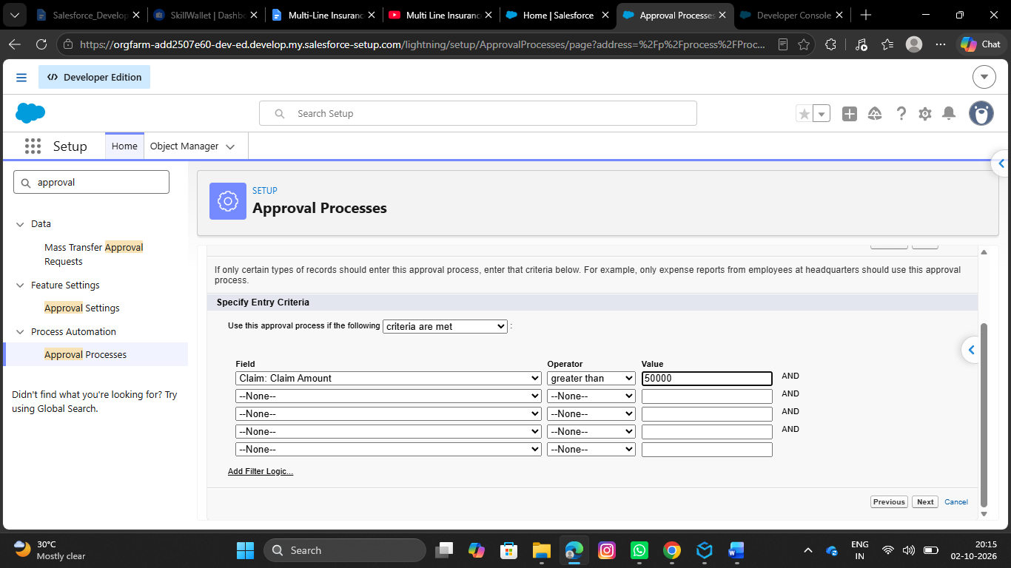
- Under Record Editability properties, Select Administrators ONLY can edit the records during the approval process
- Click on Next

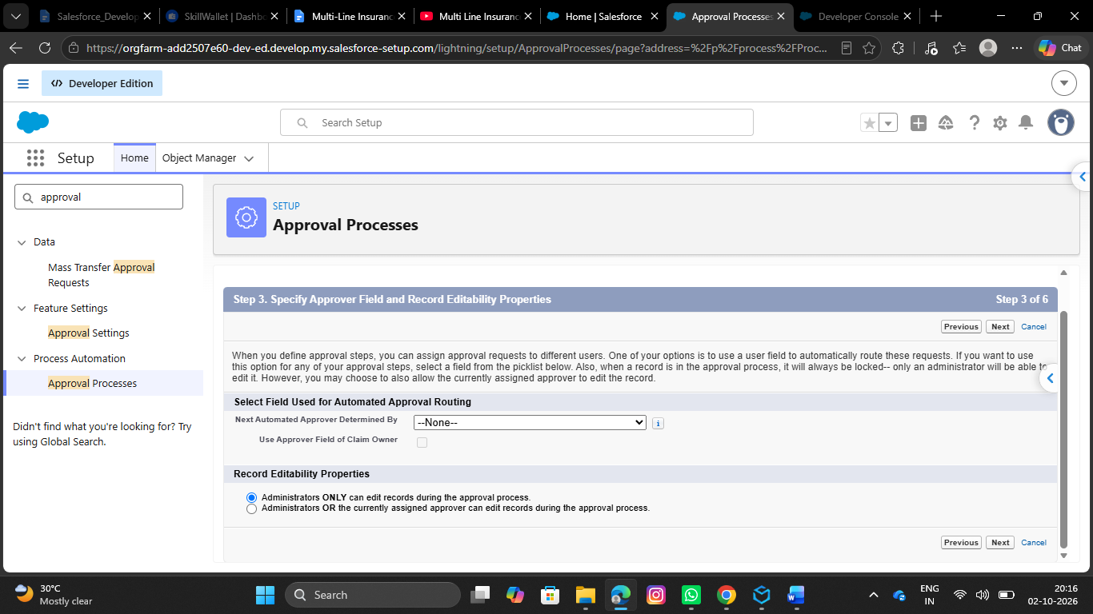
- Click on next again
- Under Approval Page Layout, Select Claim Number, Owner, Claim Amount, Adjuster, Policy fields to the selected fields from available field
- Under security settings, Select Allow Approvers to access the page only from within the salesforce application.
- Click on Next
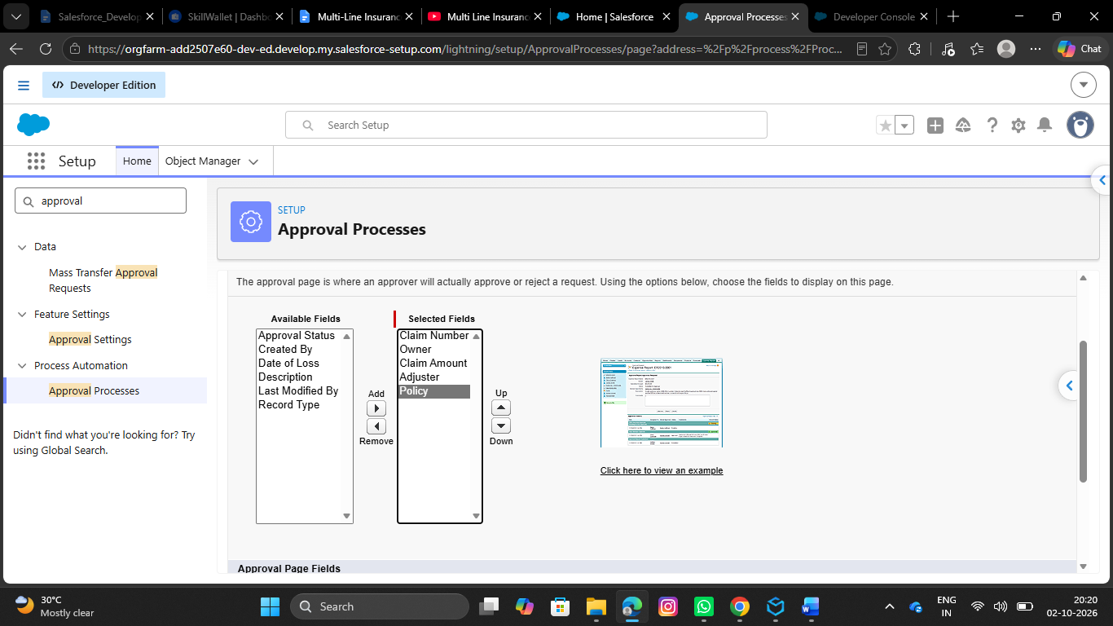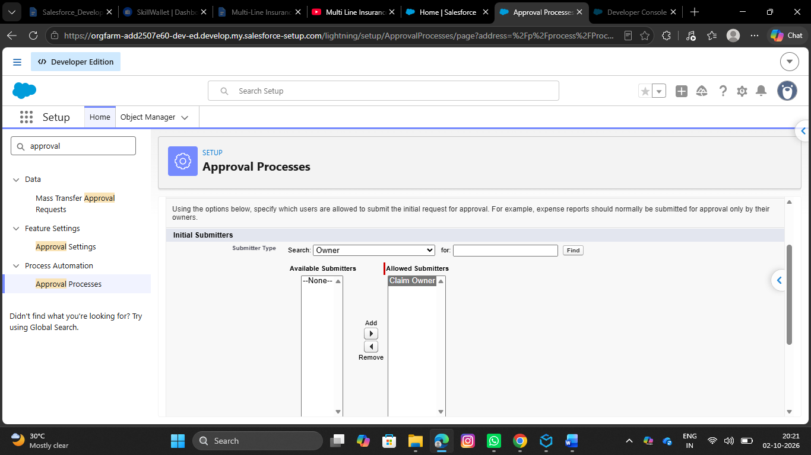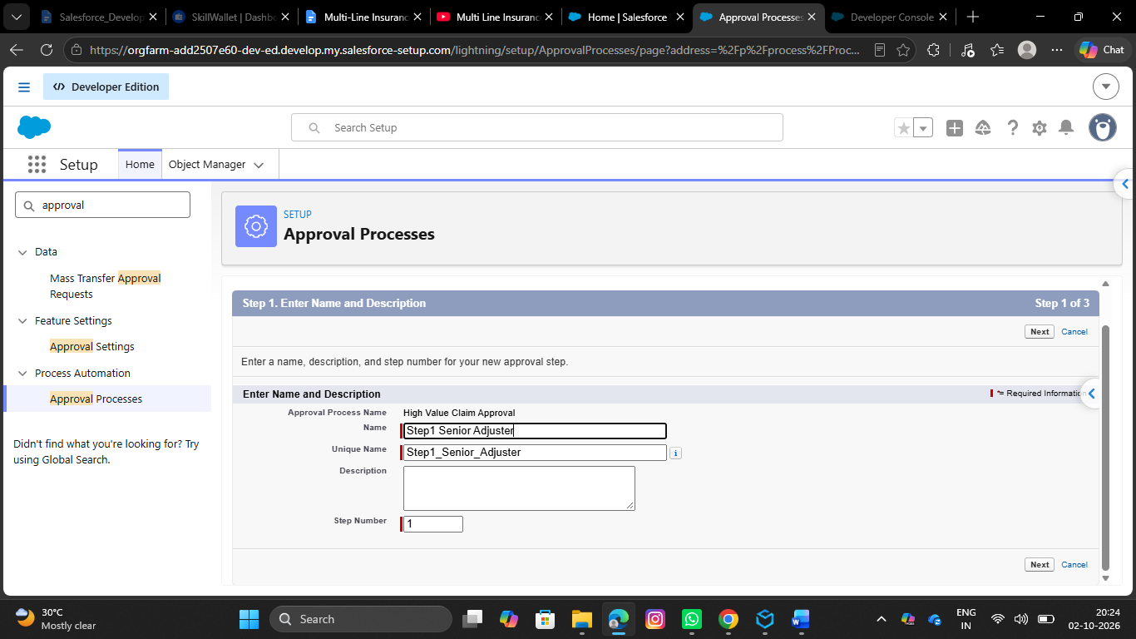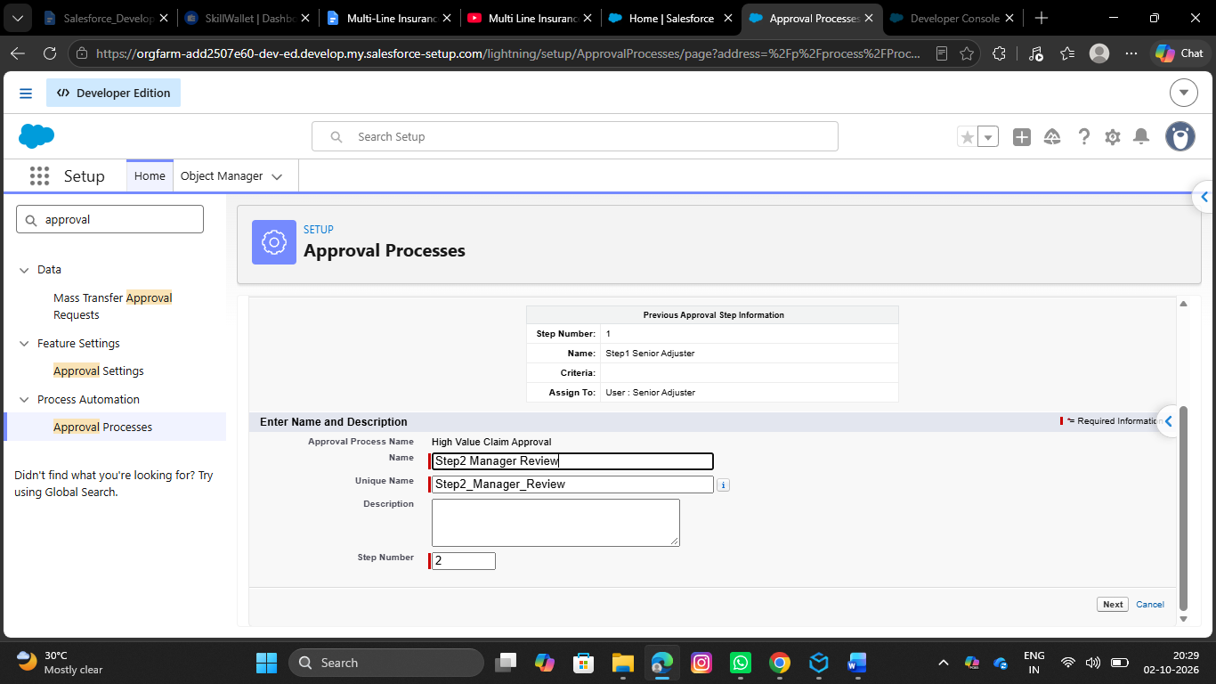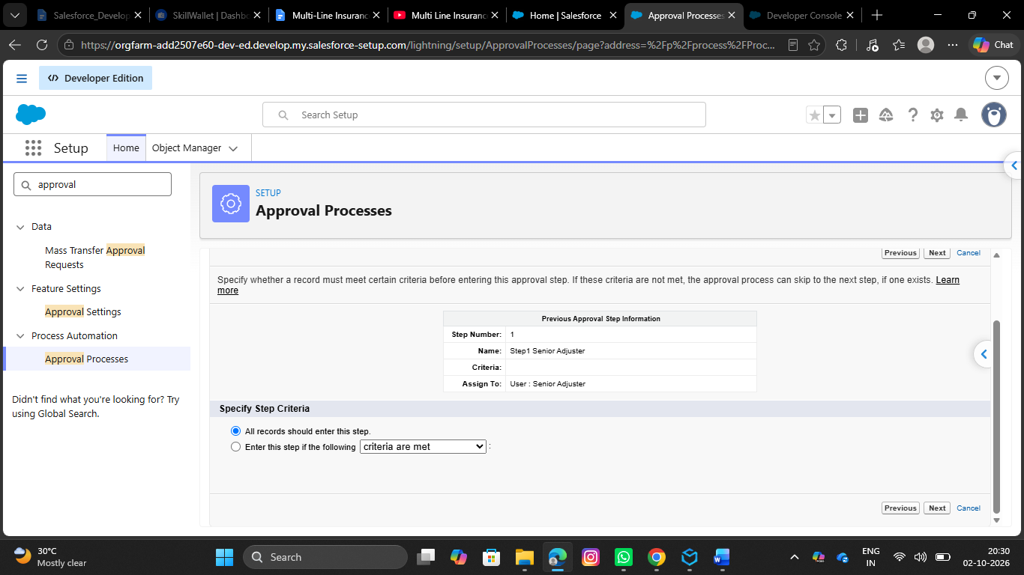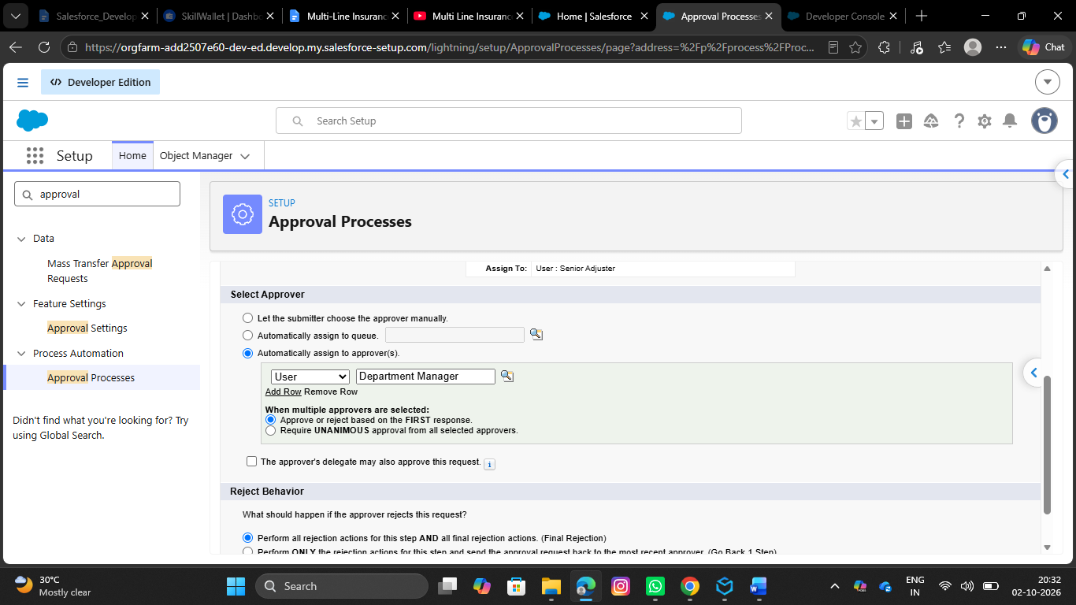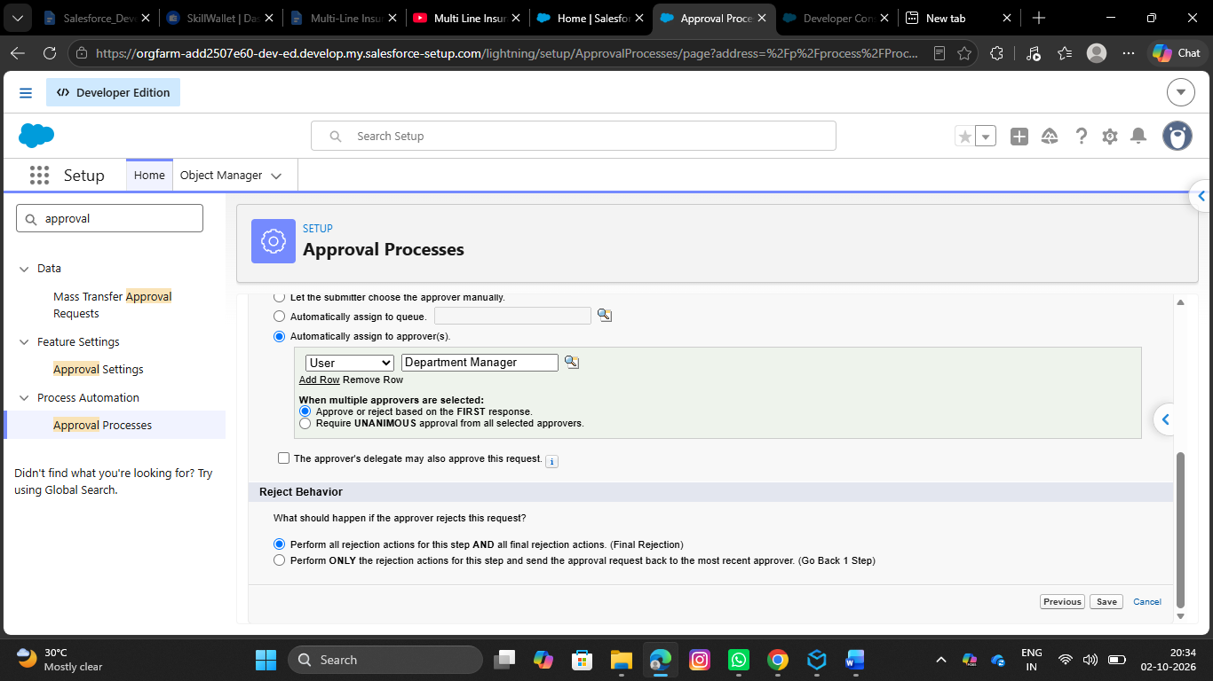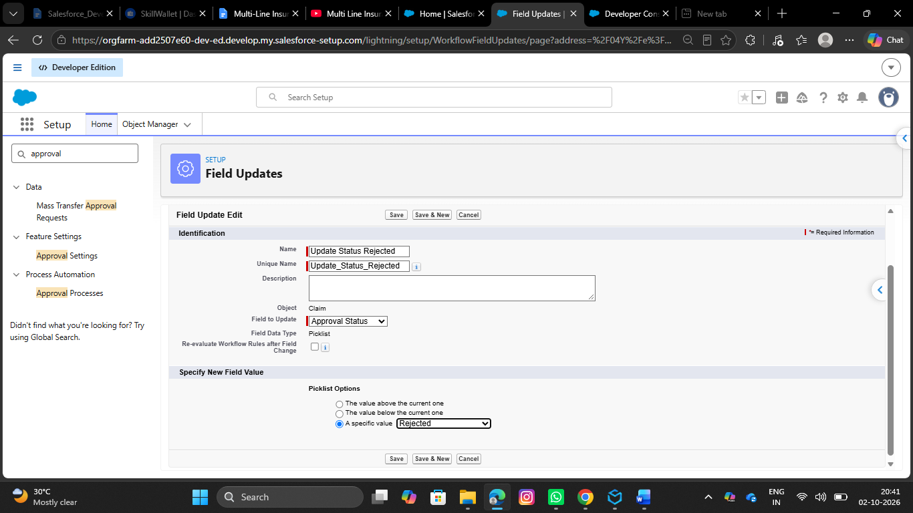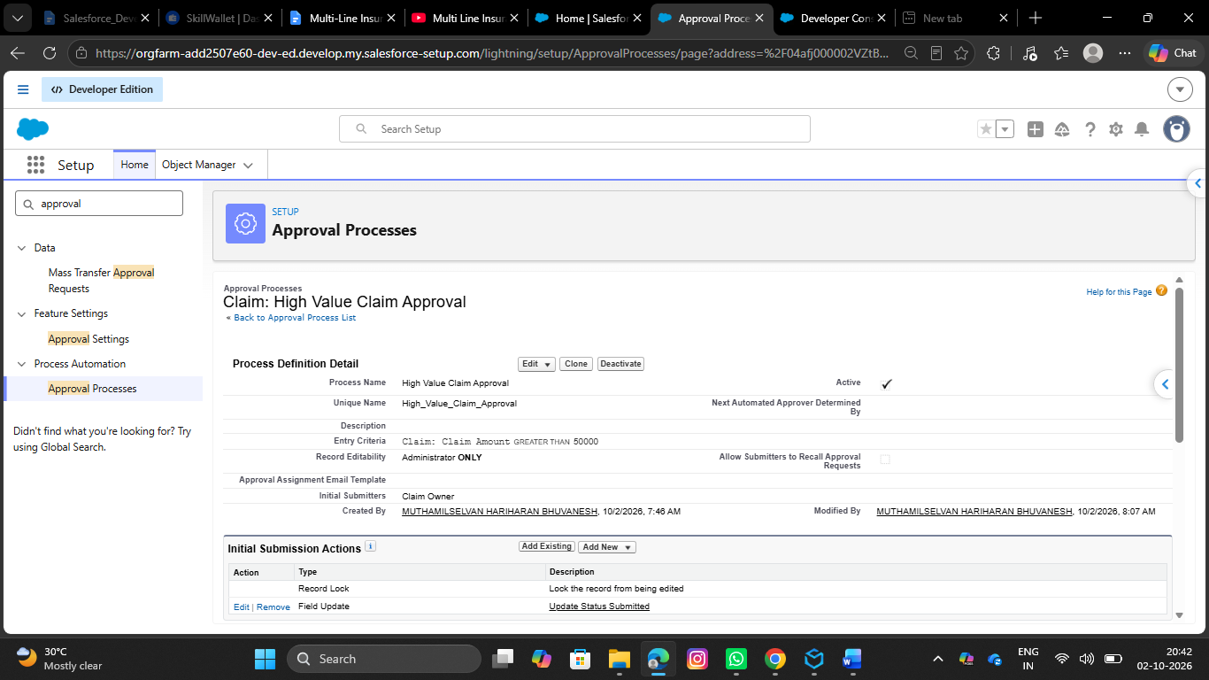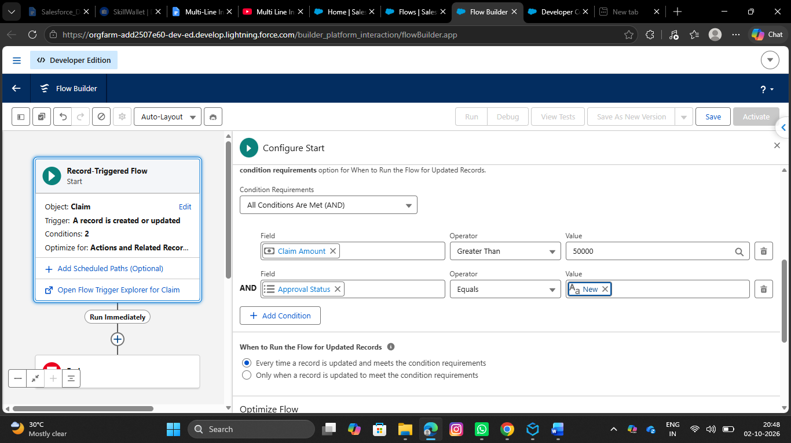

- 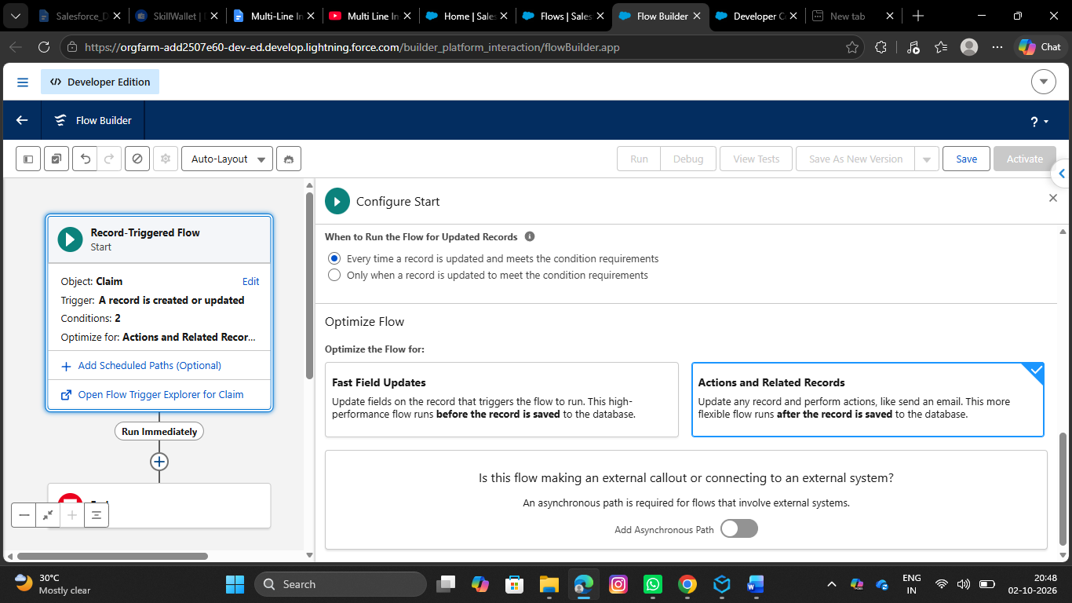 3 .Create a Record-Triggered Flow (After Save)
- Go to setup, In the quick find box, search for flows and click on flows.
- Click on New Flow
- Select Record Triggered Flow
- Select object as Claim
- Configure Trigger When a Record is created or updated
- Select All conditions are true for conditional requirements

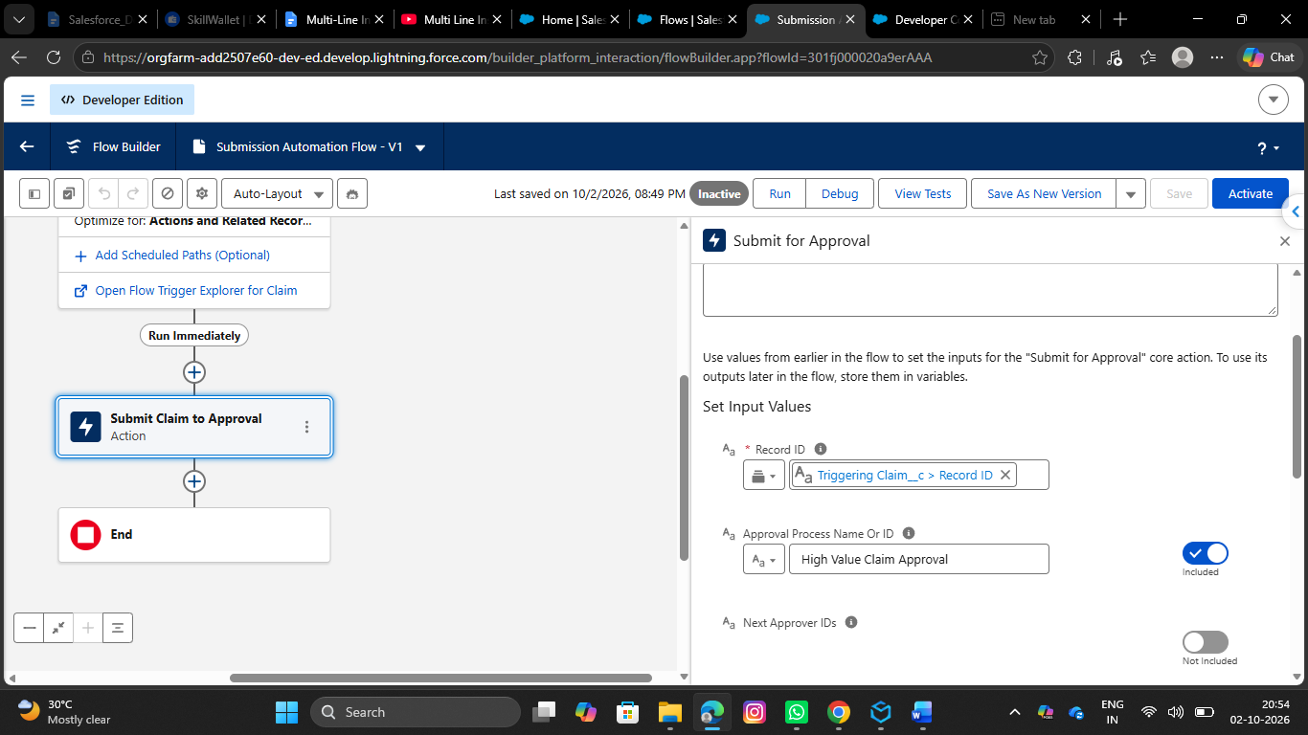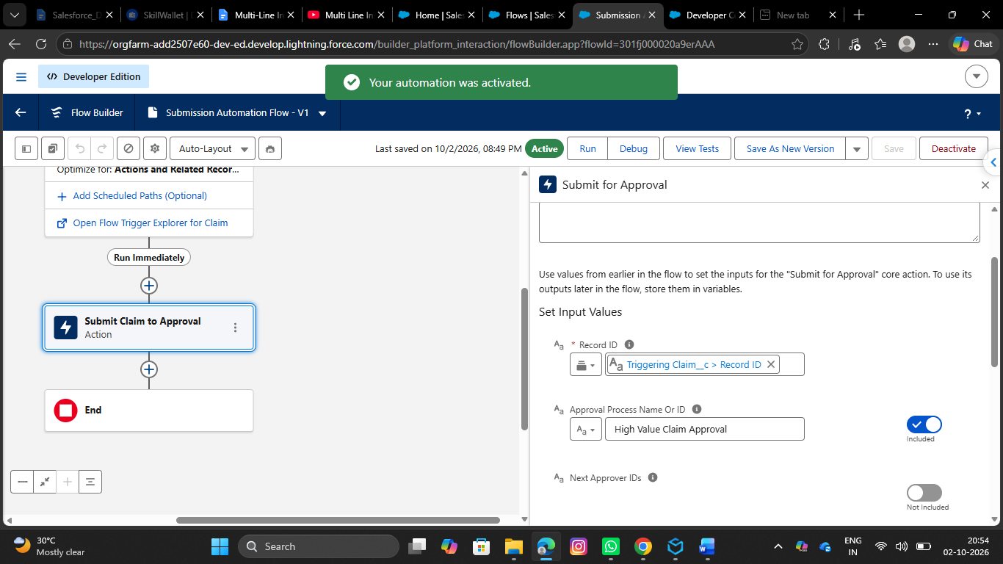

- 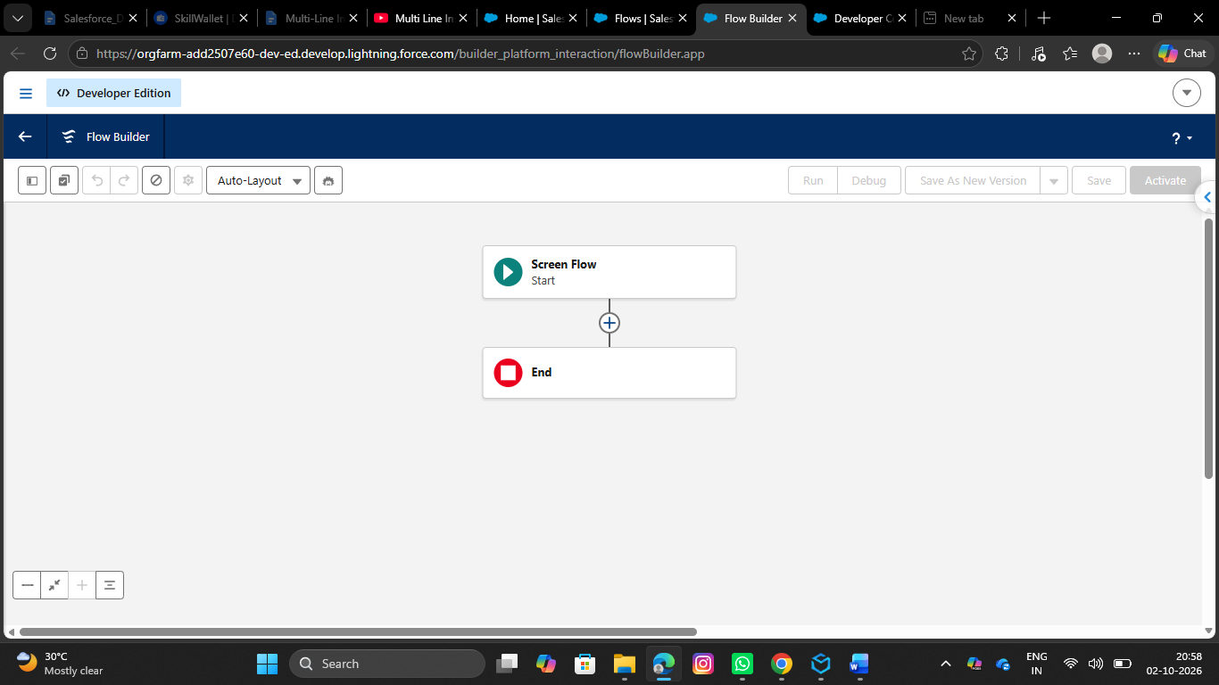4 .Implement a Screen Flow for the approvers to quickly review details and approve/reject directly from the Claim record.
- Go to setup, Search for flows in the quick find box and click on flows.
- Click on New Flow, Choose Screen Flow
- Create a New Resource by clicking on New Resource button in the toolbox manager
- Resource Type would be Variable
- API Name would be recordId
- Data type would be Text
- Under Availability outside the flow, Check Available for Input
- Click on Done
- Add the Get Records Element below the screen
- Label it as Get Claim Details
- Select object as Claim
- Select All conditions are required for conditional Requirements
- The Condition include:

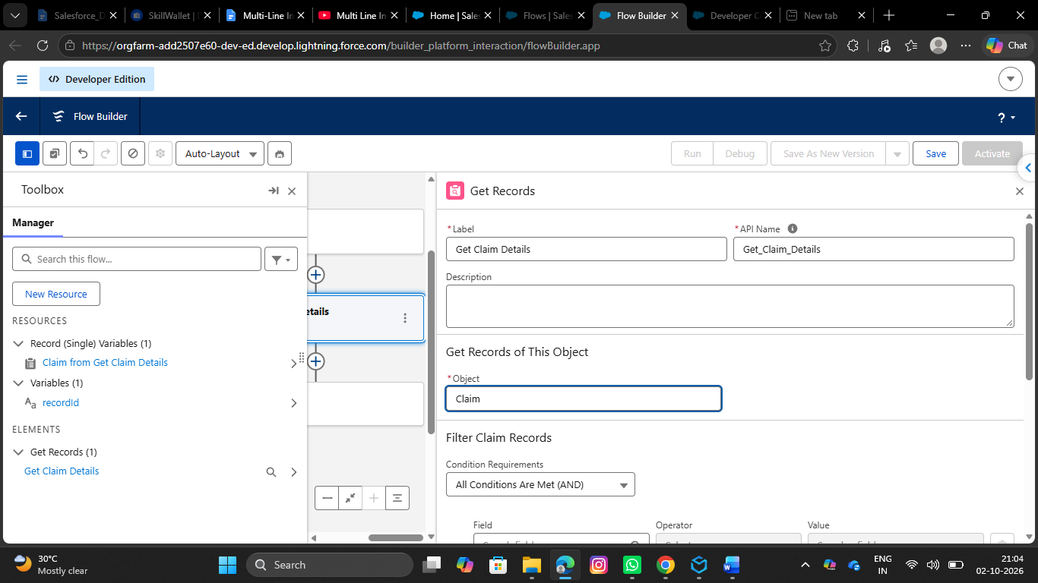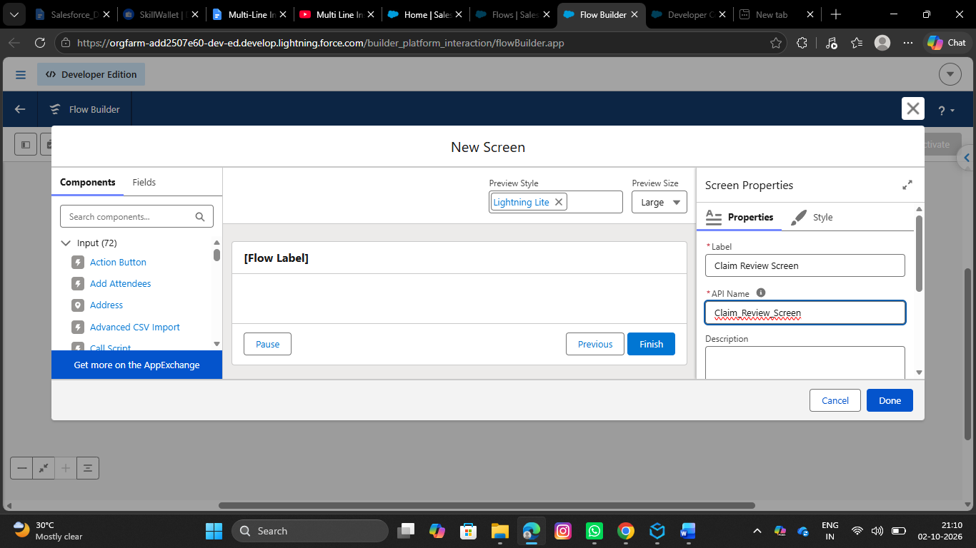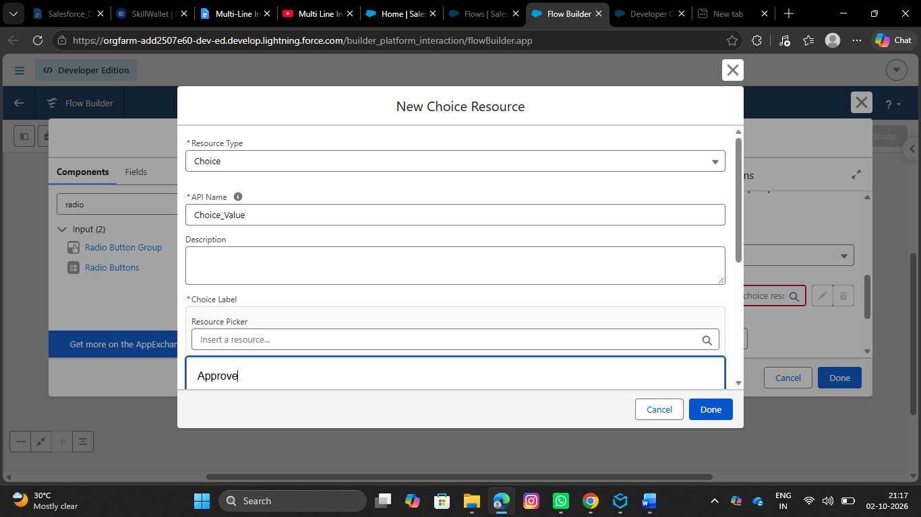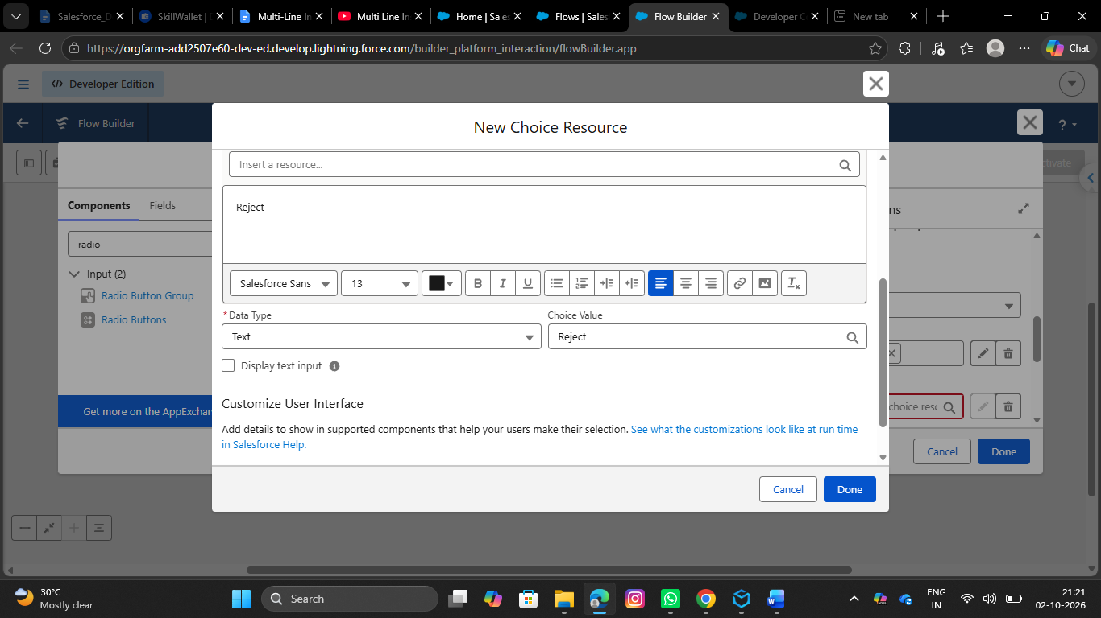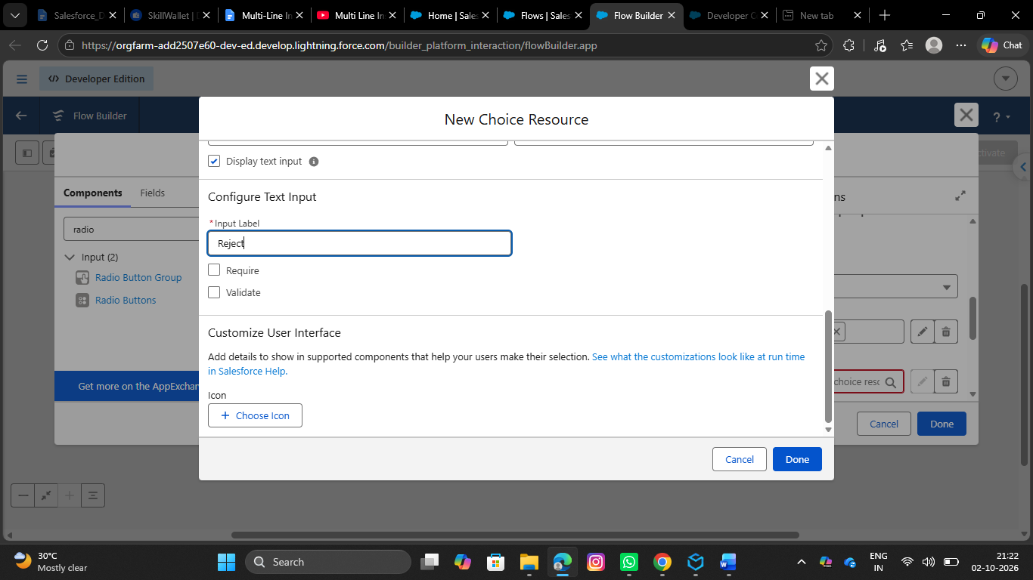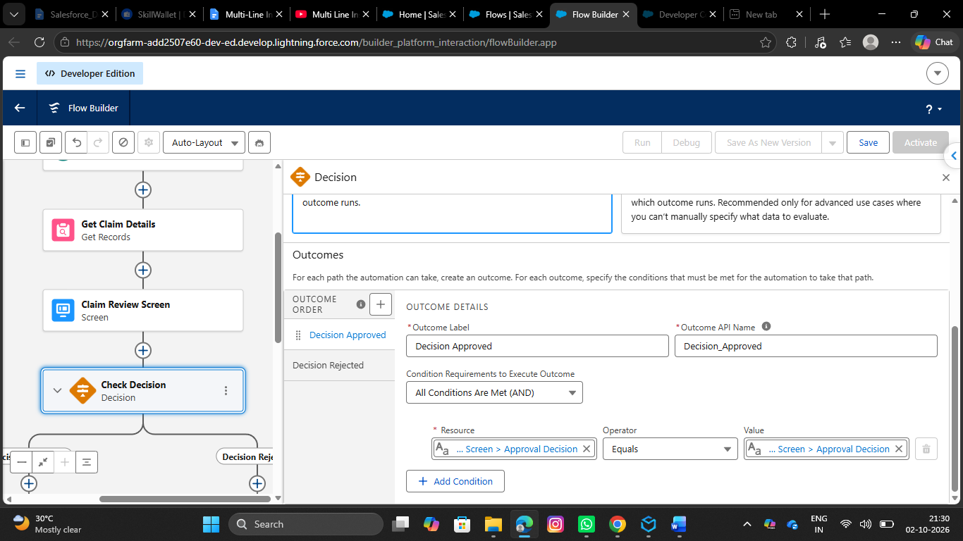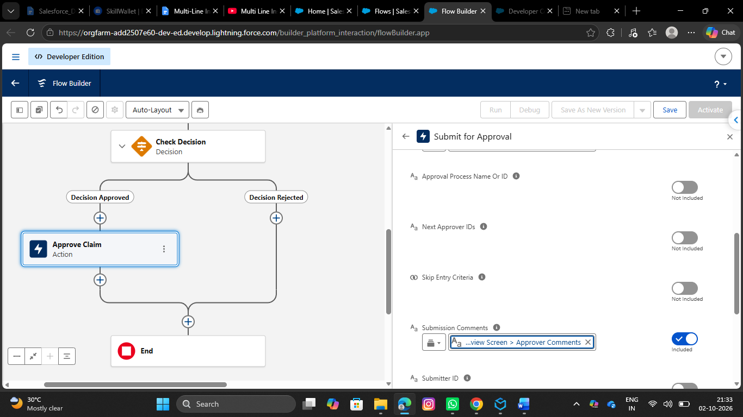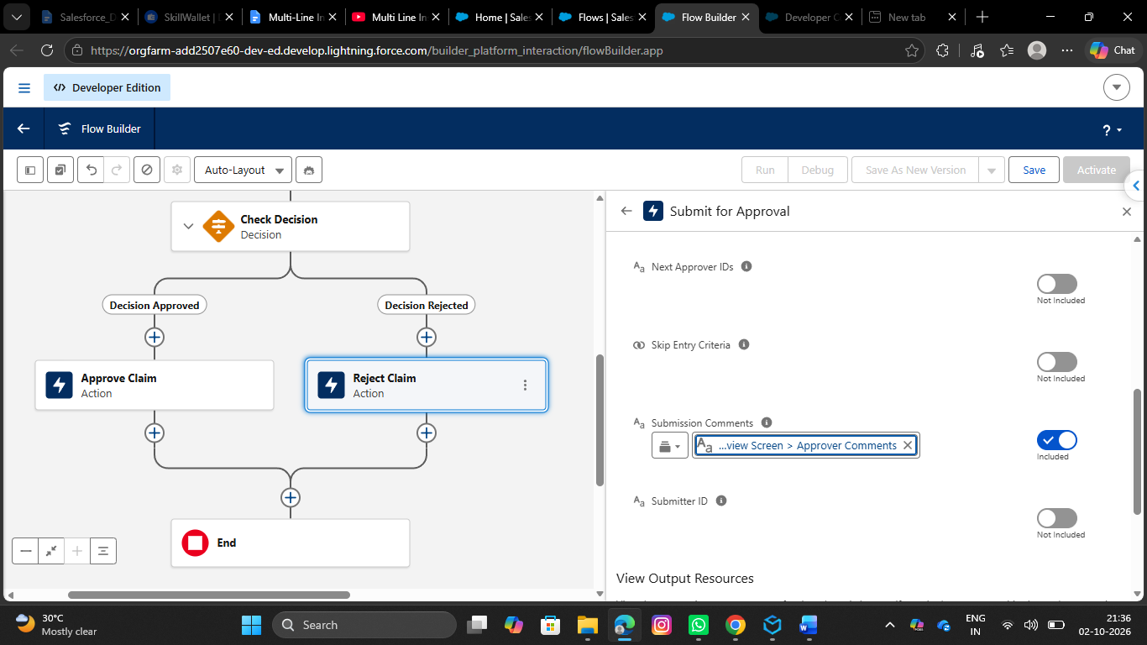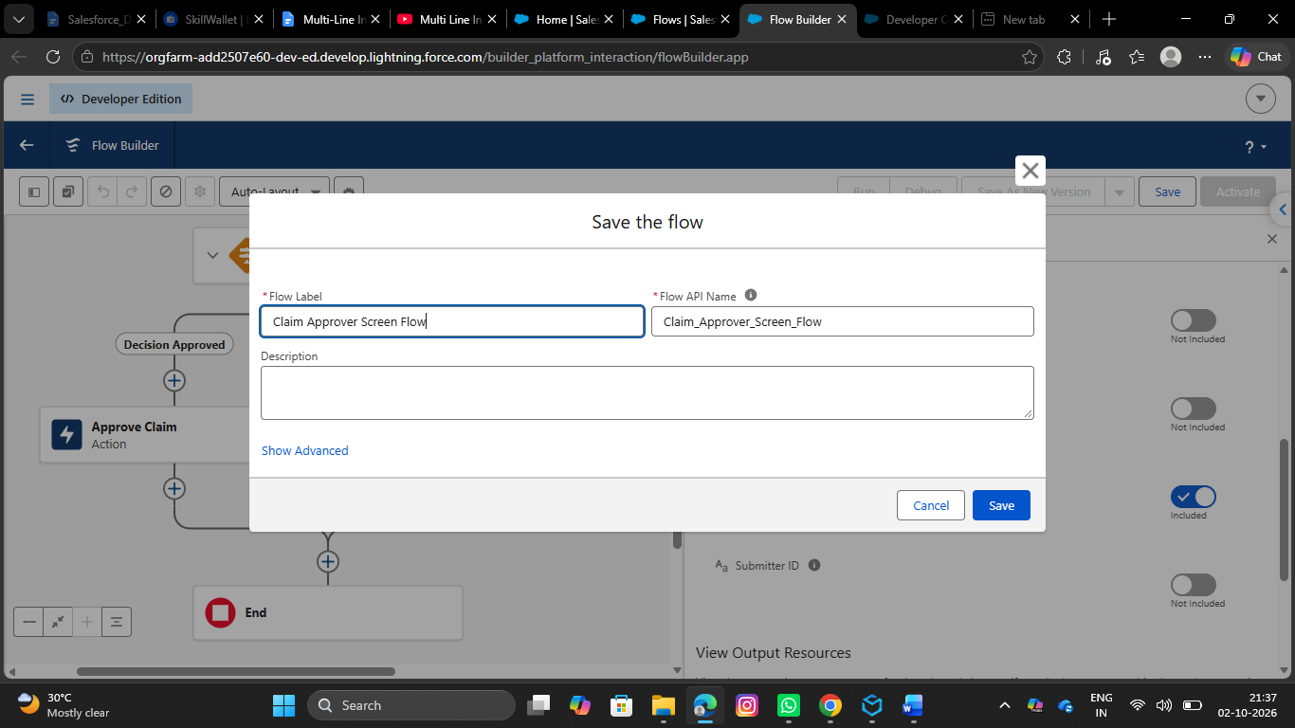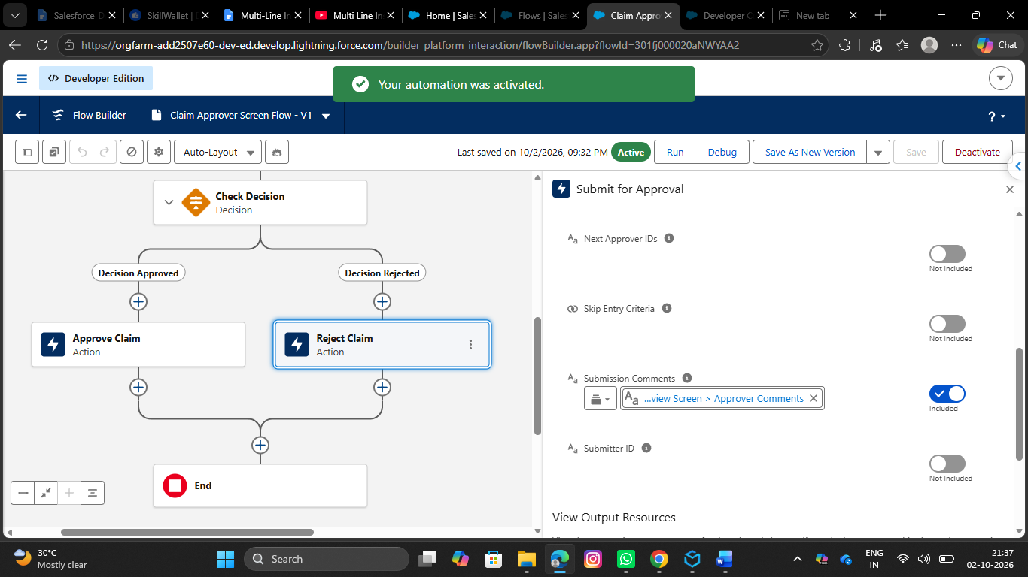

5.Write an apex test
the ClaimsAdjusterController with 95%+ code coverage. Include test methods for complex claim filtering and data retrieval logic

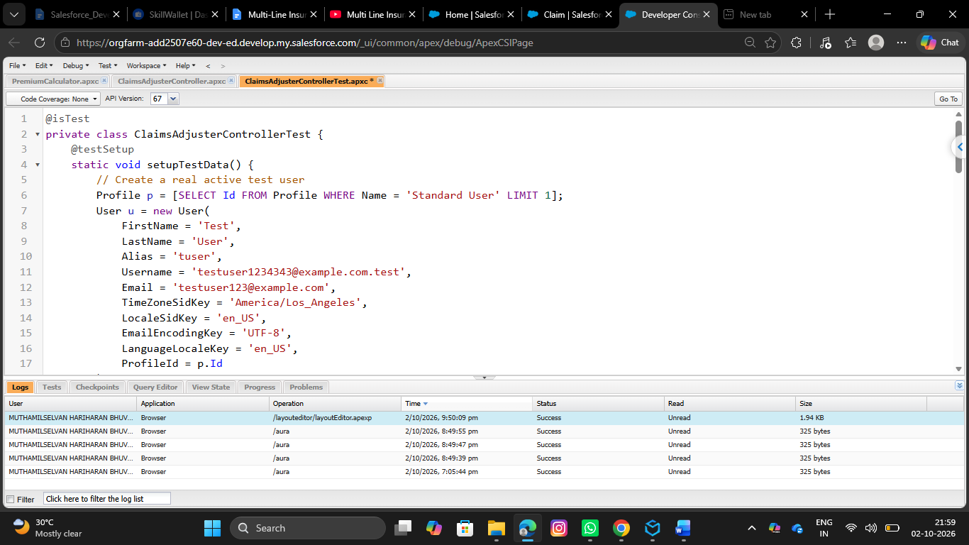
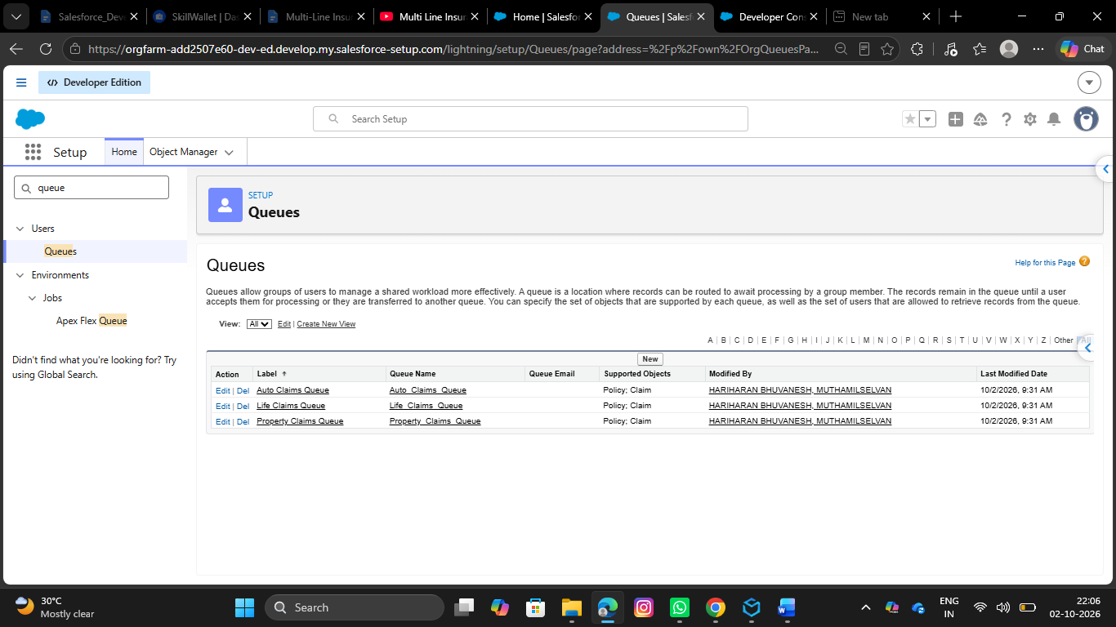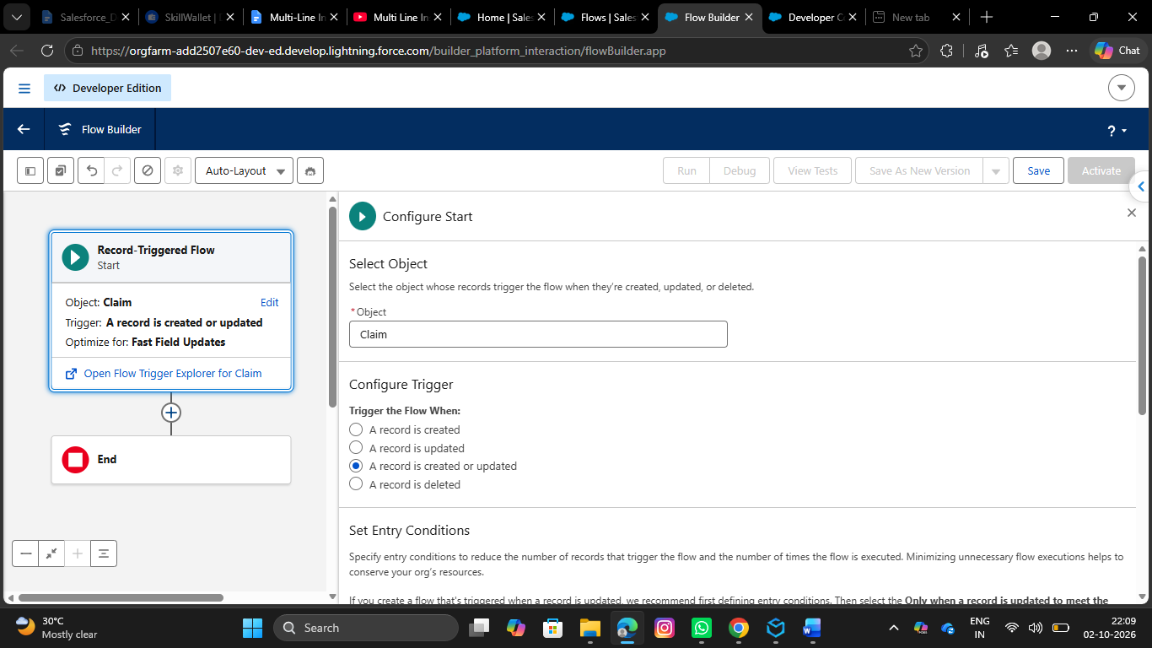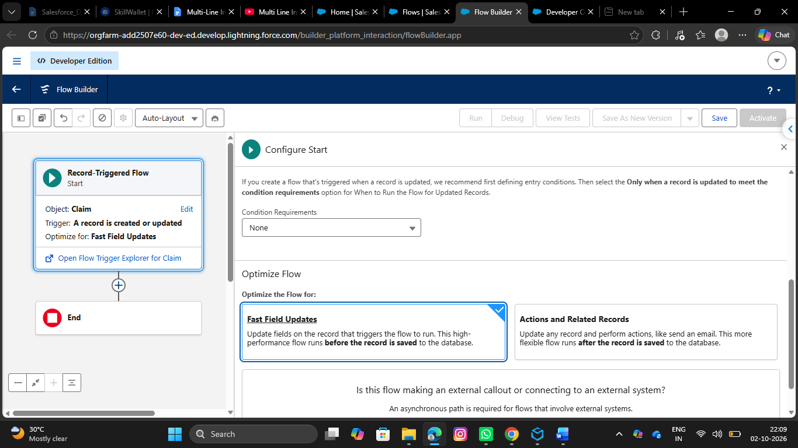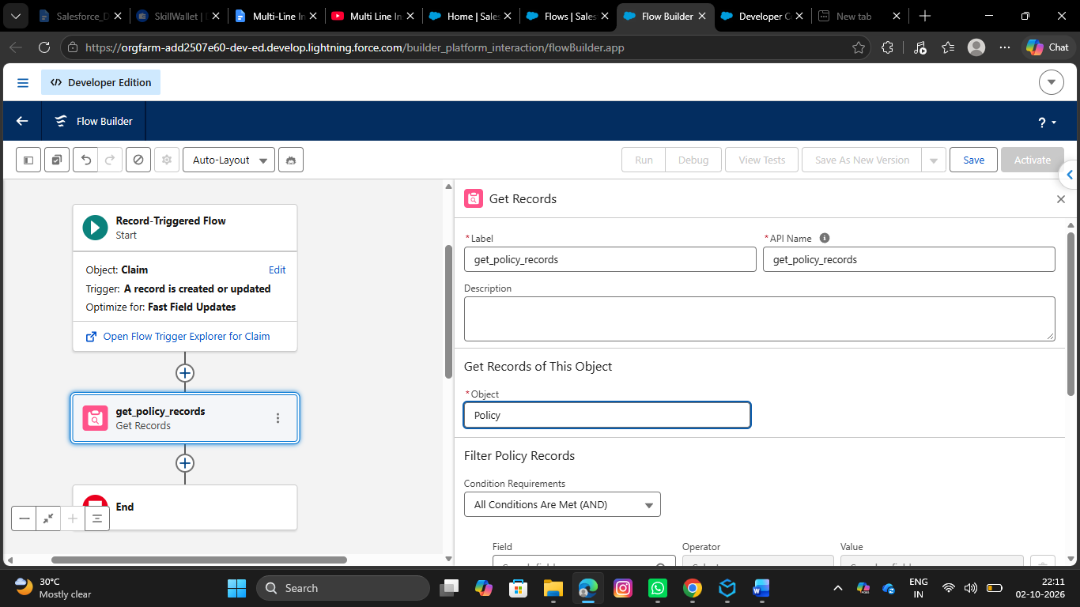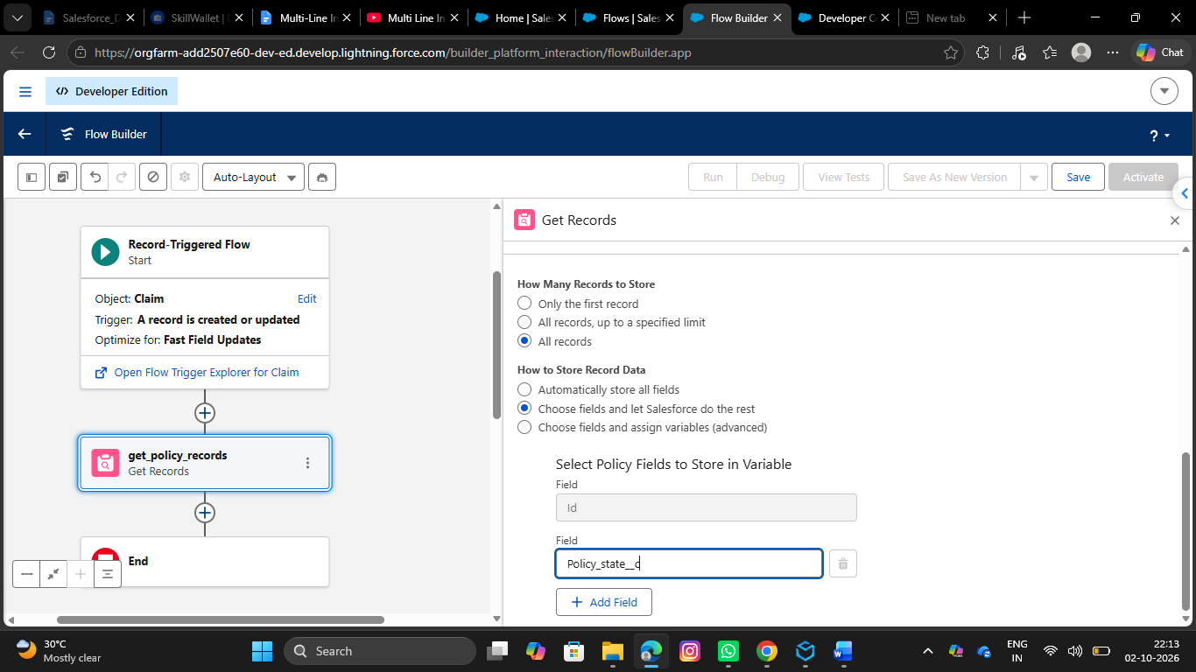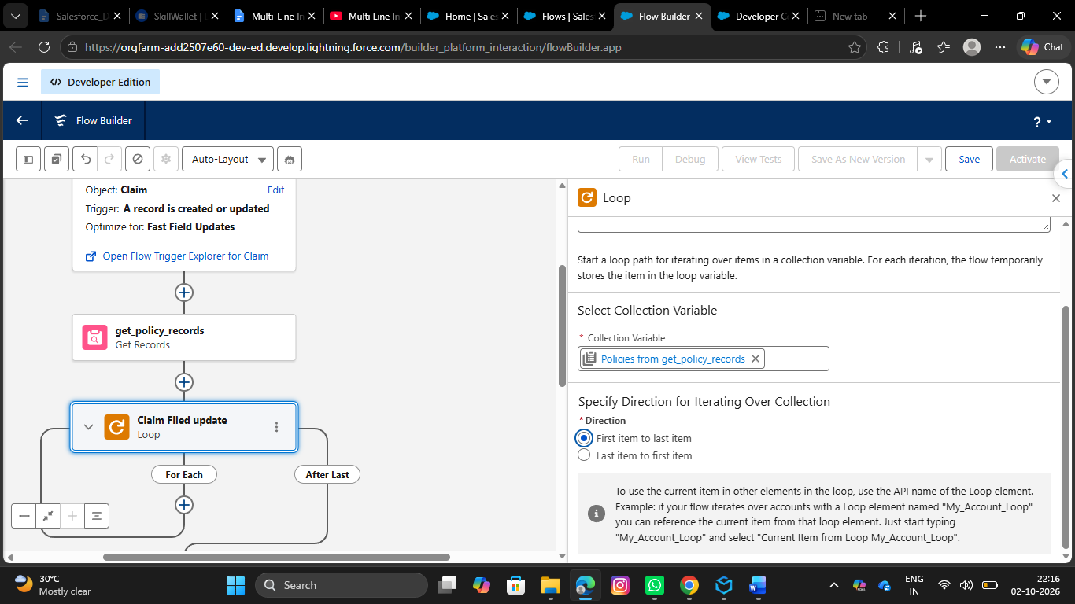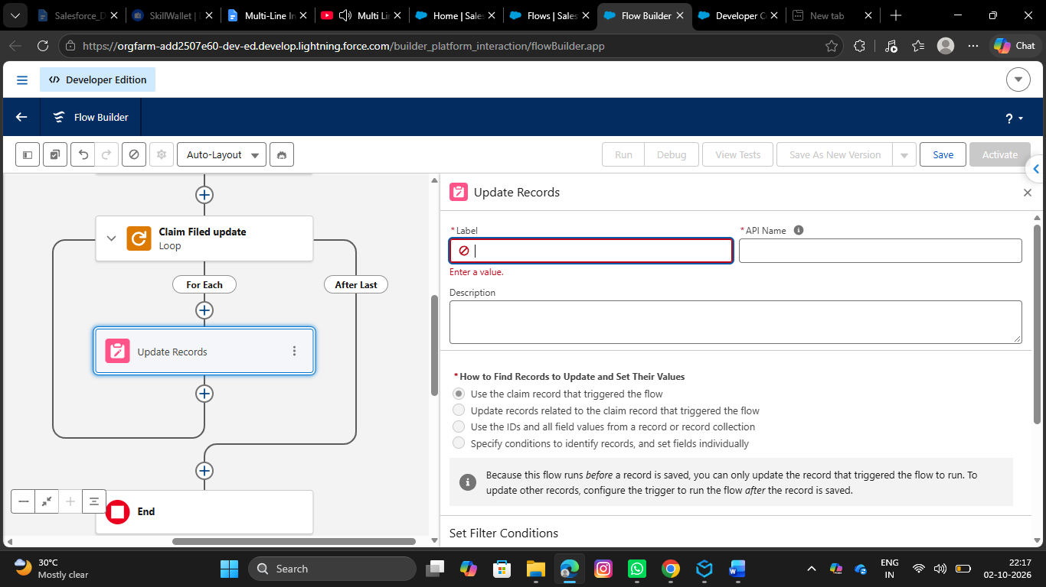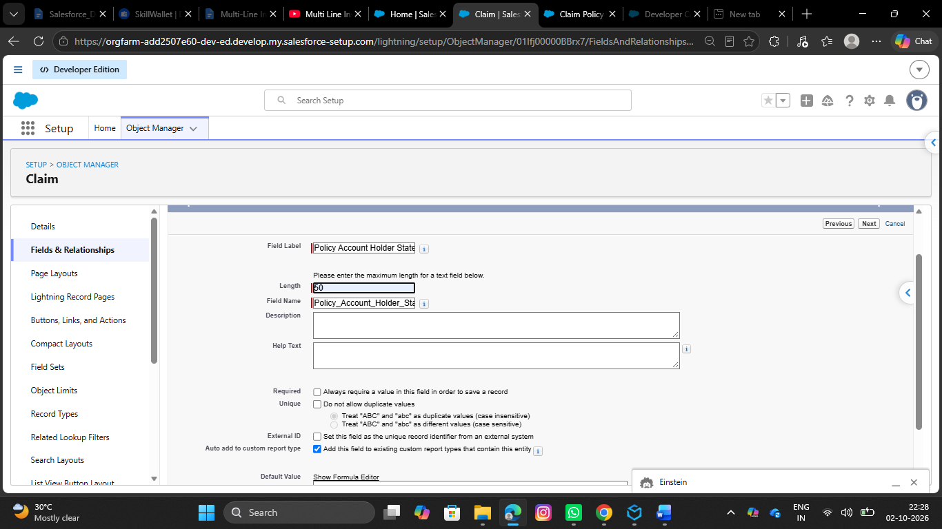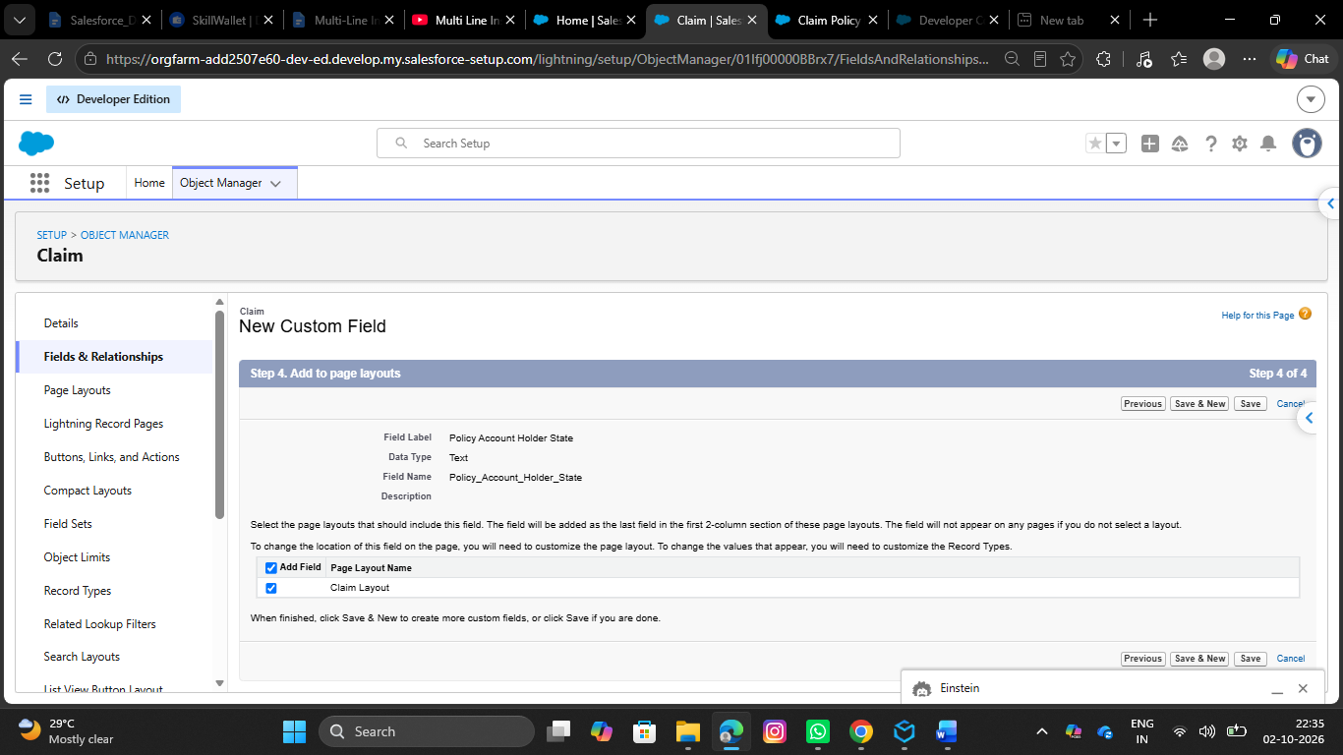

- Refine the Sharing Rules to ensure Adjusters
- Go to setup, Search for flows in the quick find box and click on flows
- Click on New Flow
- Select Record Triggered Flow
- Select the object as claim
- Configure trigger when a record is created or updated

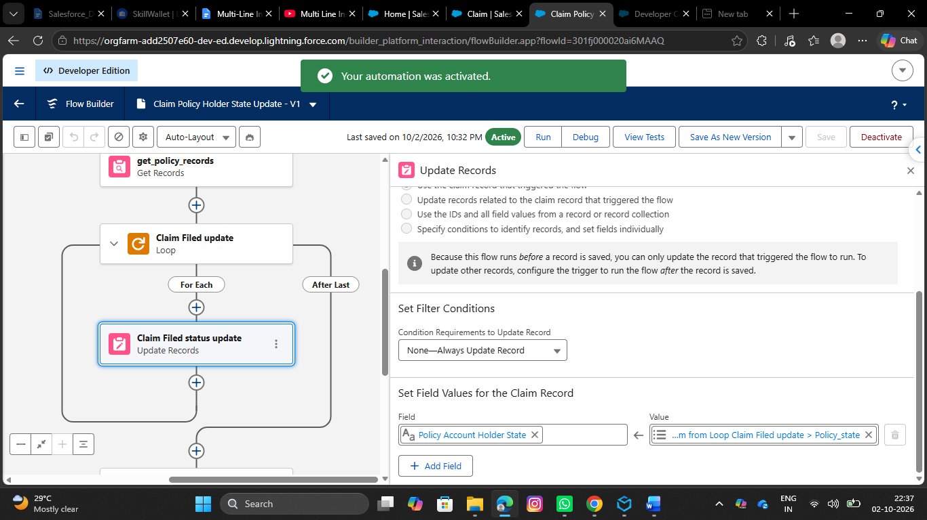
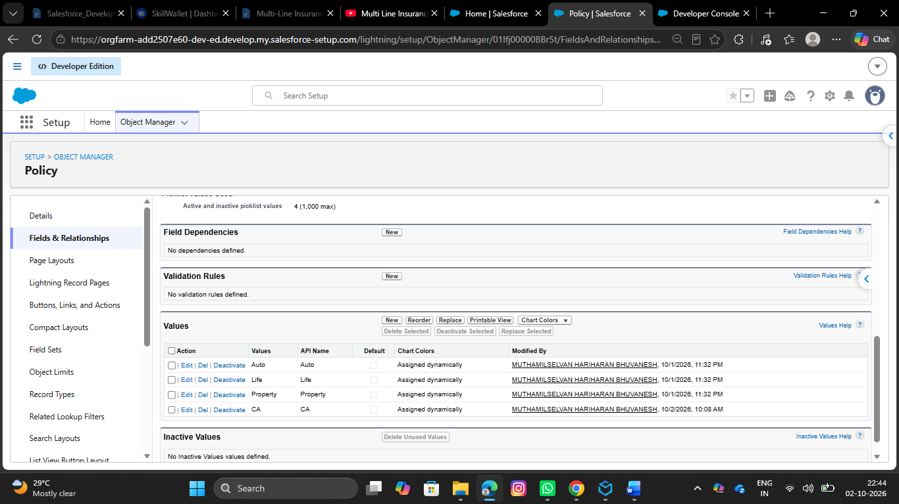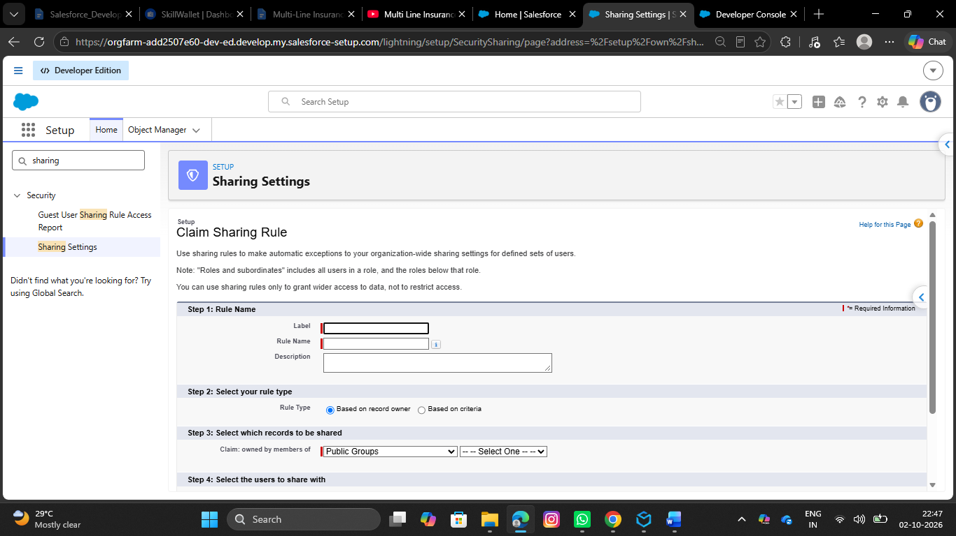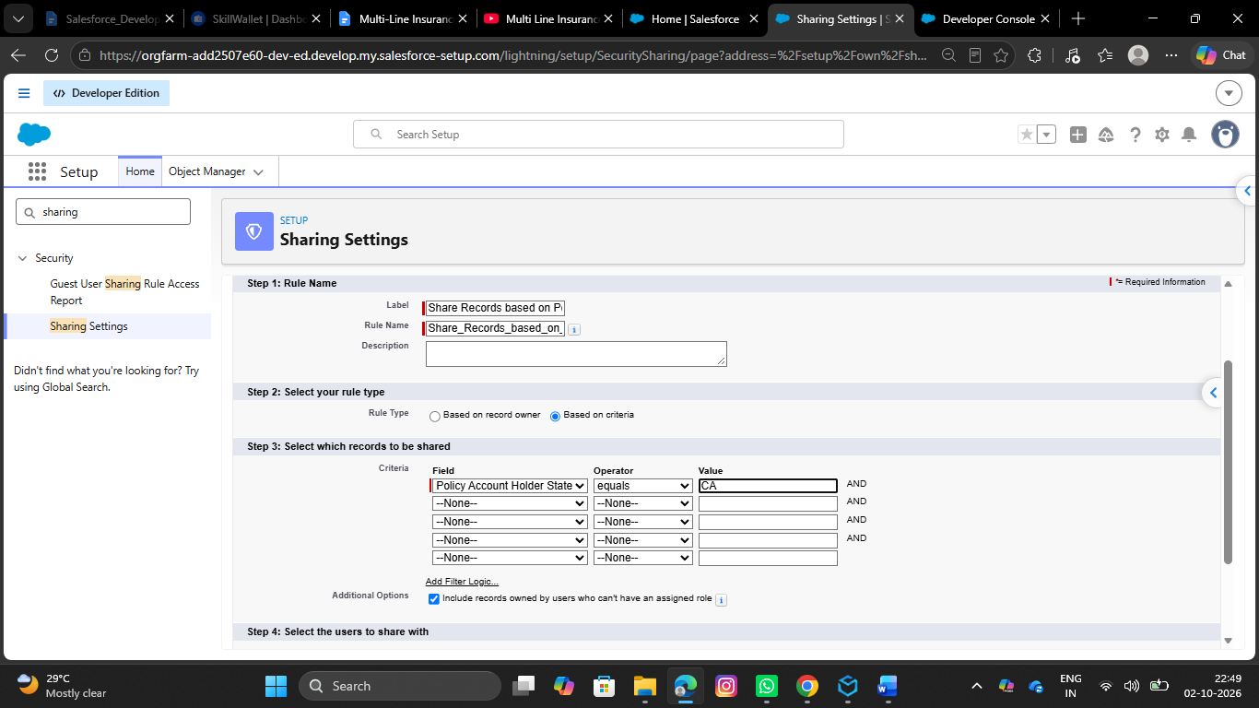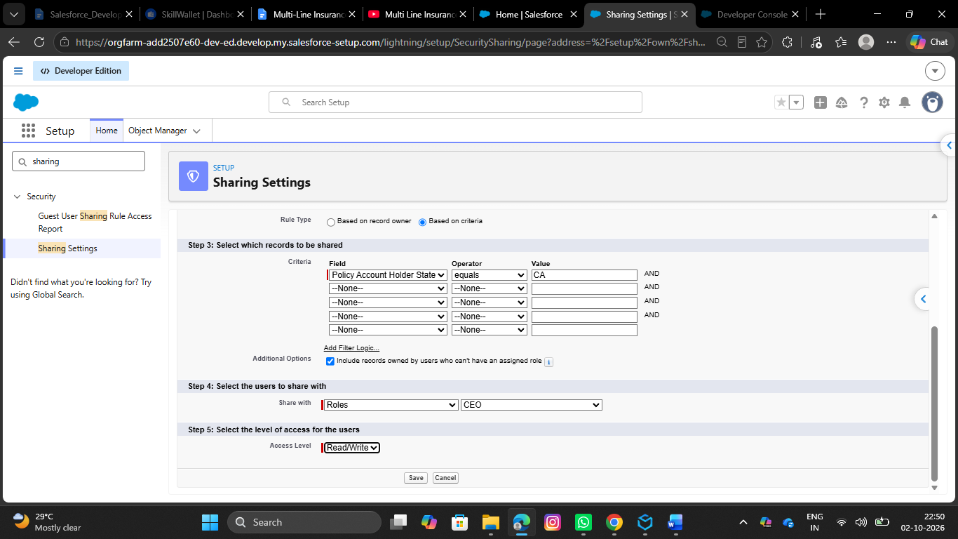

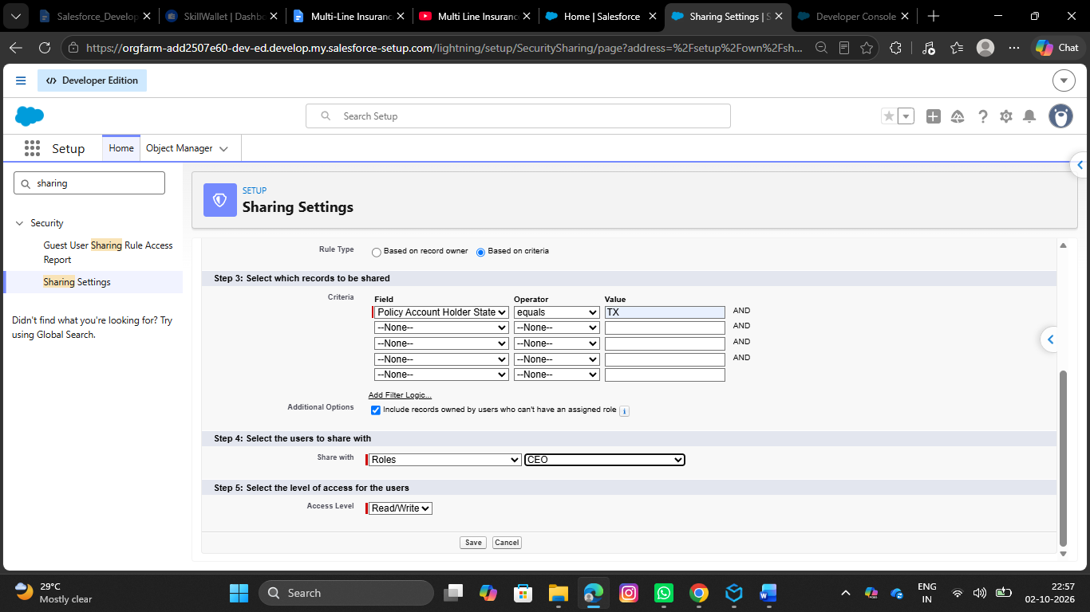
- Finalize all Permission Sets
- Go to setup, In the quick find box, Search for Permission Sets, Click on Permission Sets
- Click on New
- Give the Label as Insurance Agent Access
- API Name will be Auto Populated

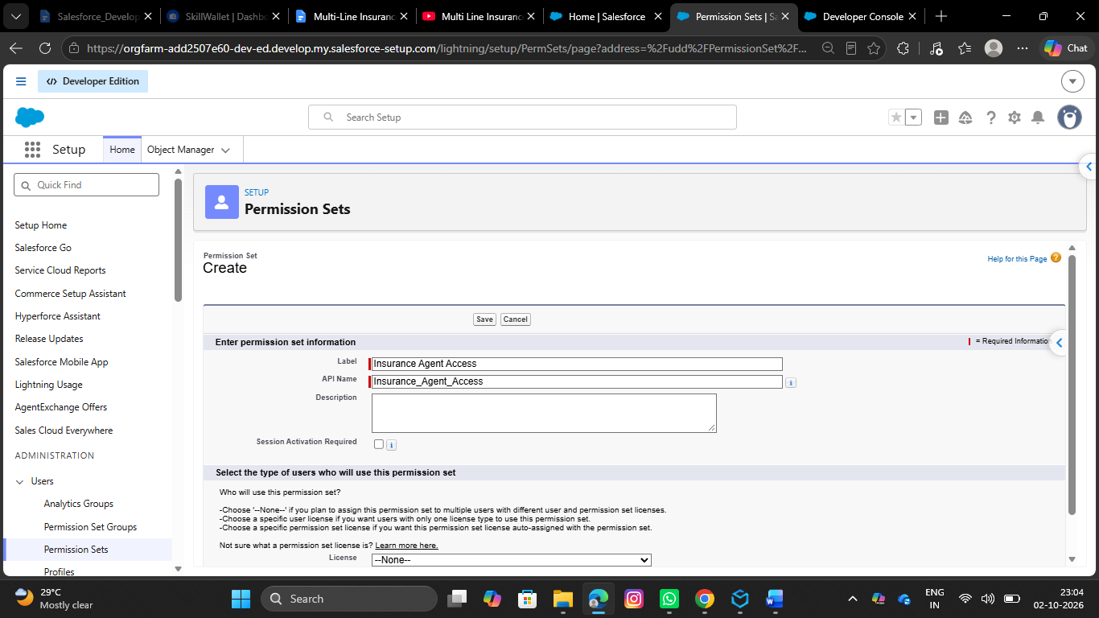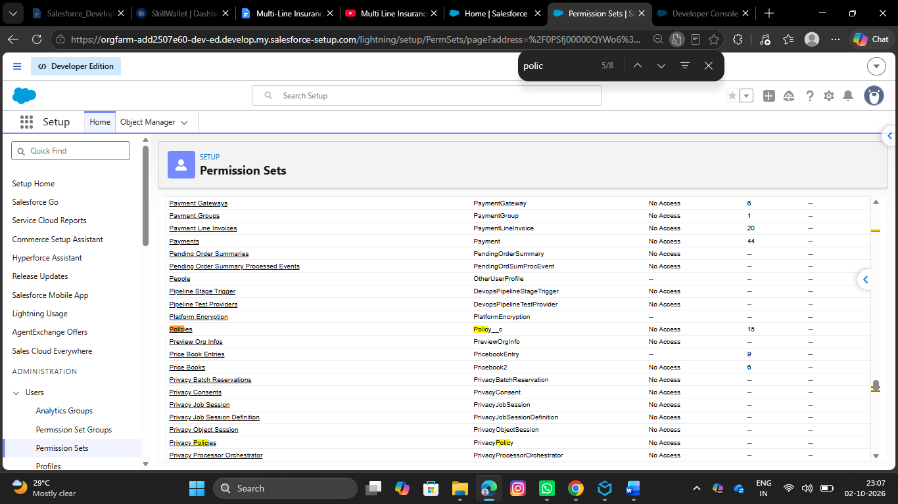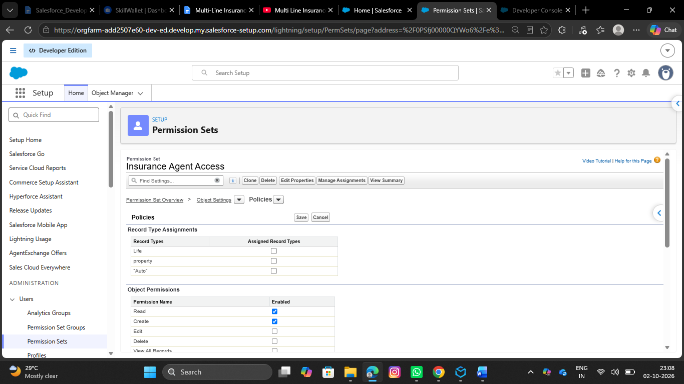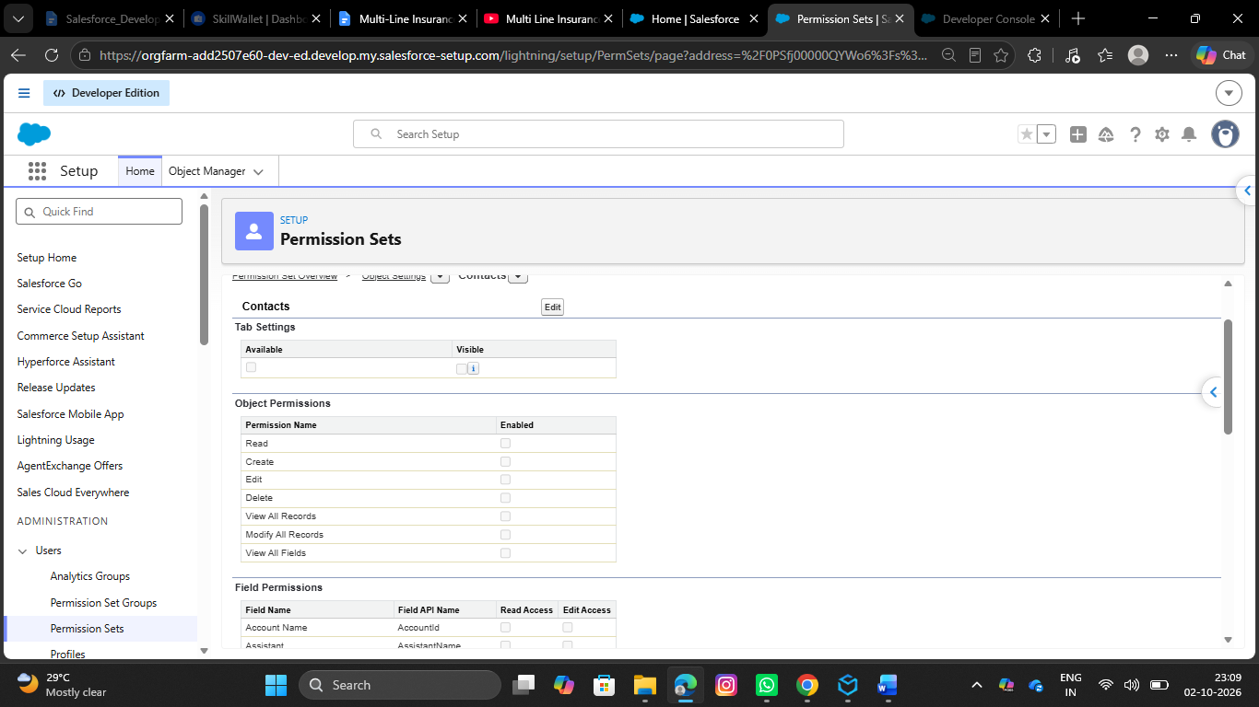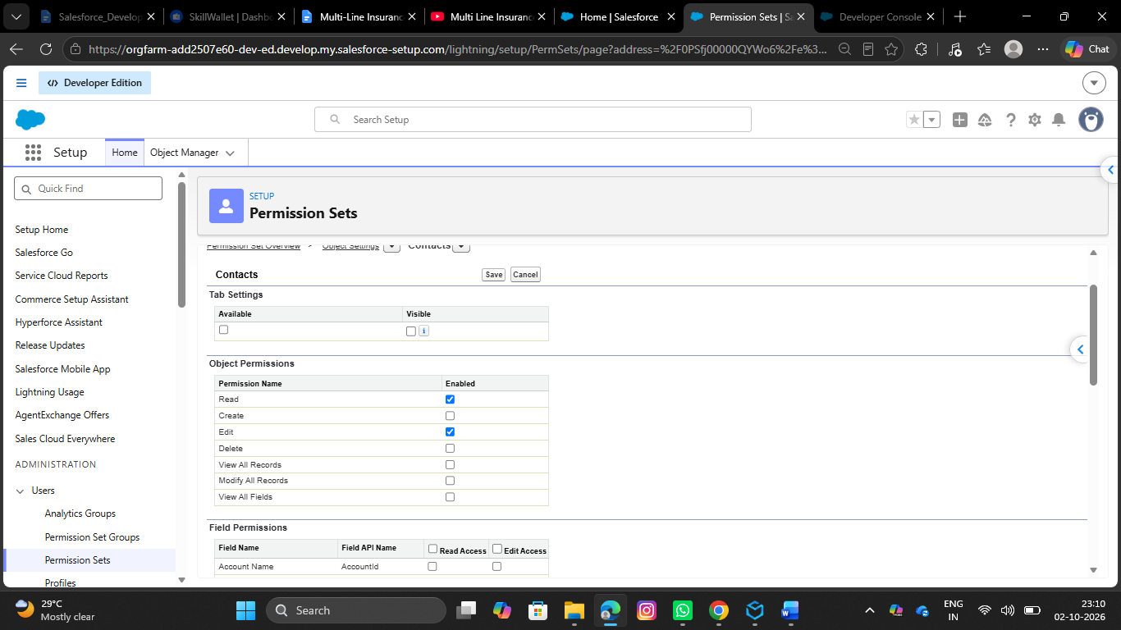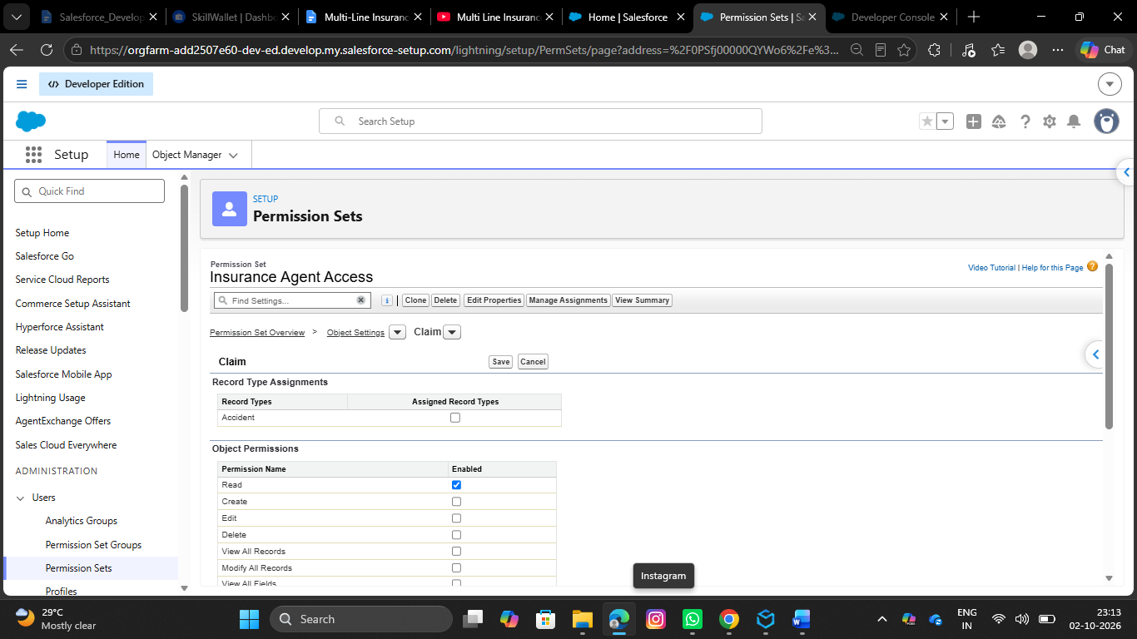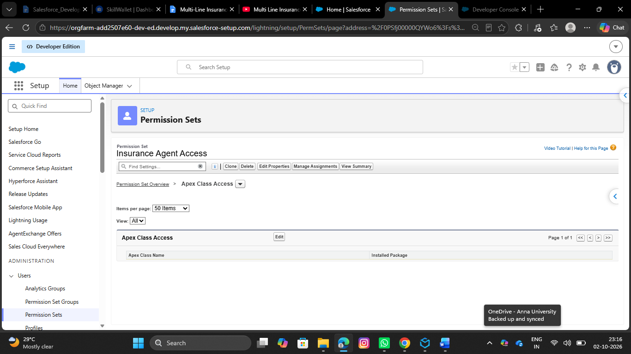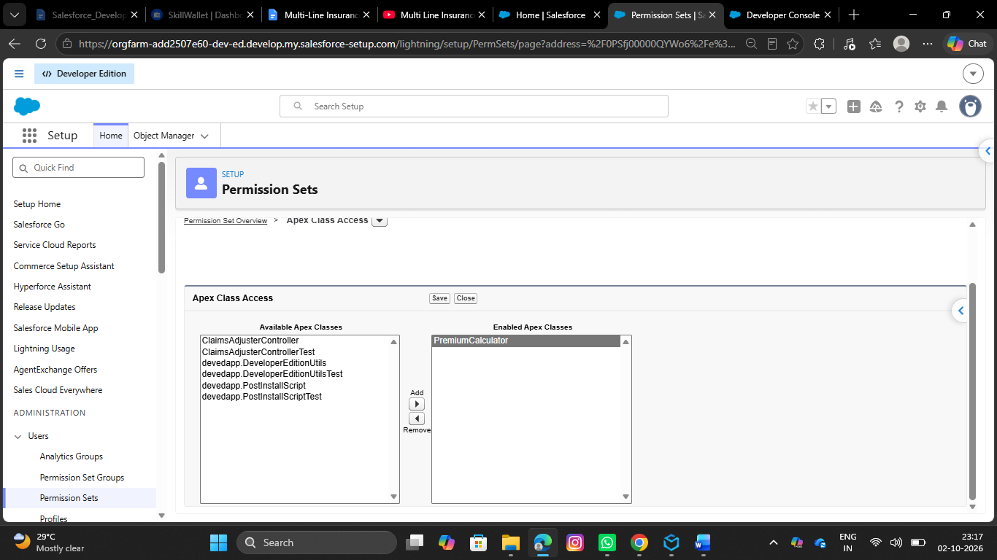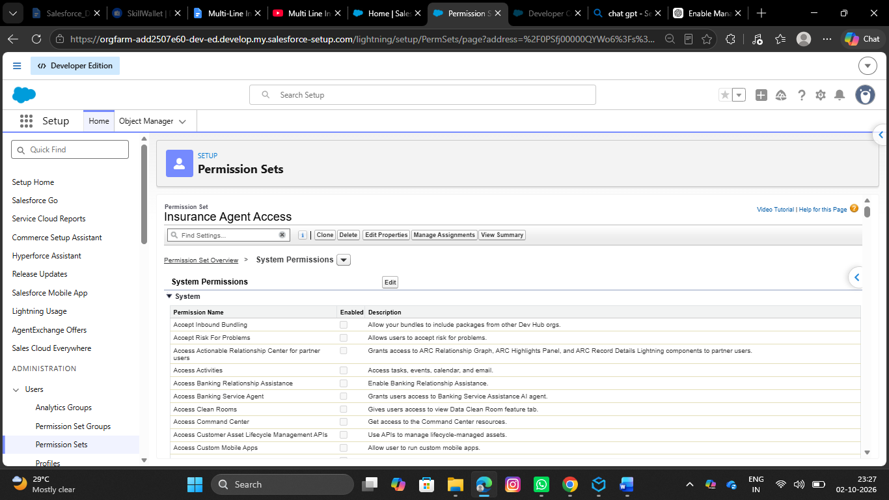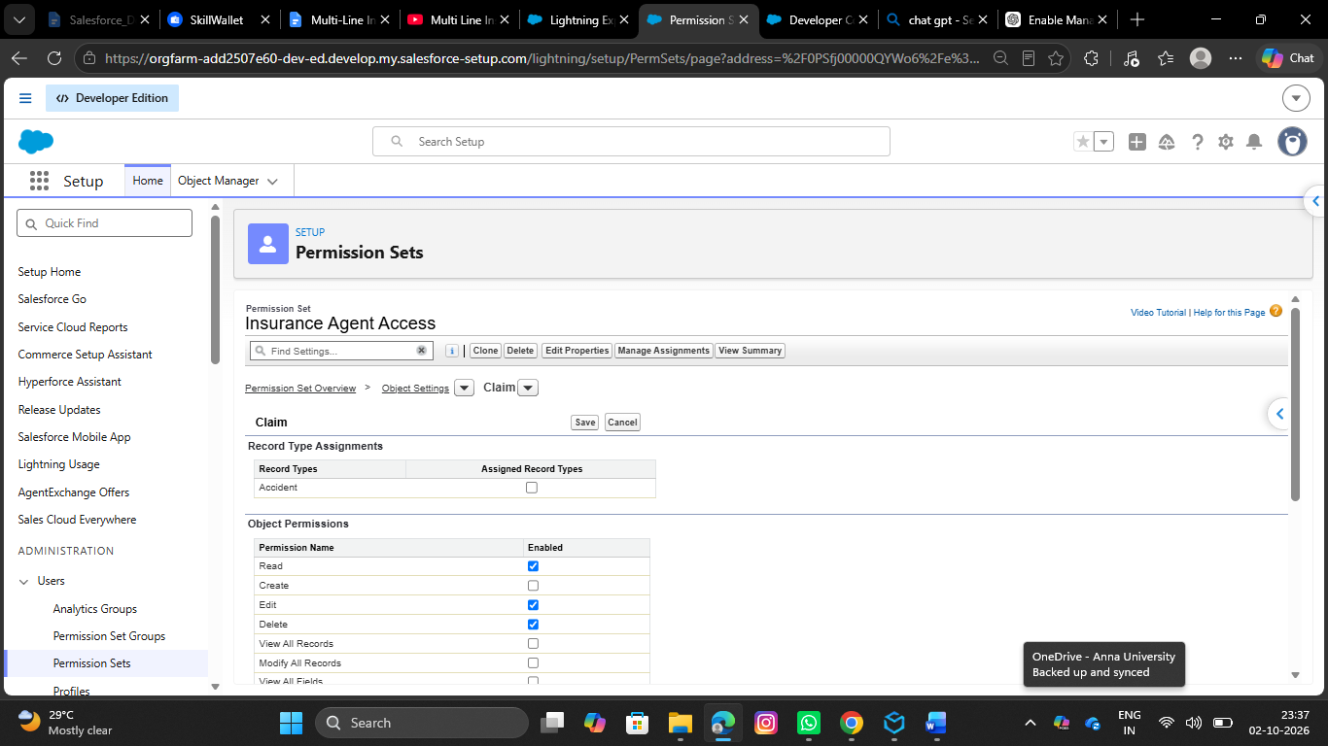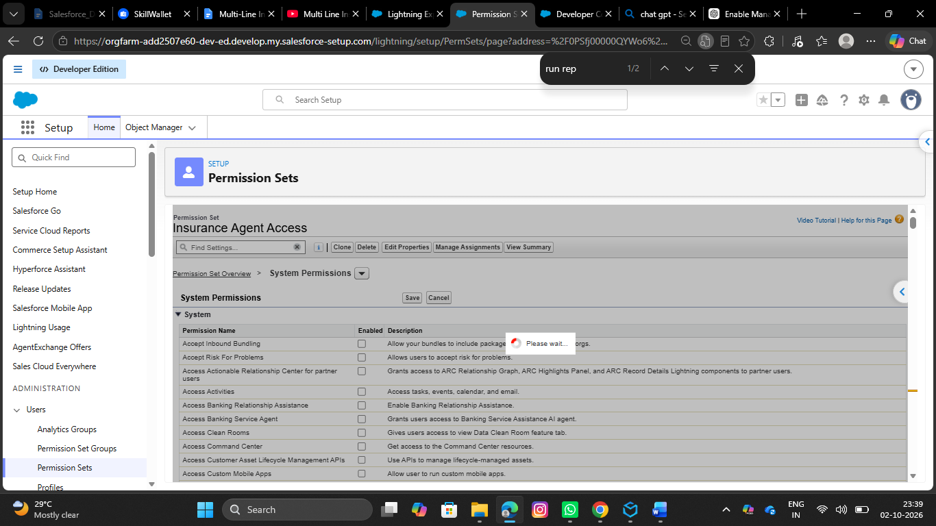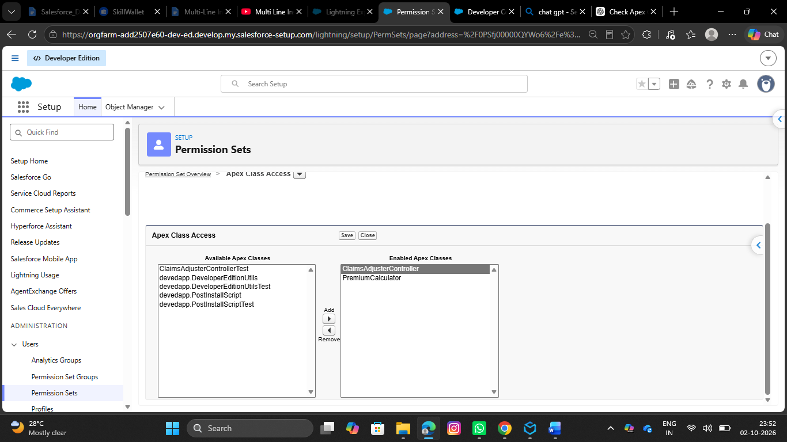
- Give the access to objects
- Give Read Only for Policy object
- Give Read, Edit to Claim object
- Make ClaimsAdjusterController Enabled under Apex Classes

